**INVENTORY MANAGEMENT SYSTEM FOR KIDS’ WEARS**

**BY**

**HAFSAT MAHMUD WAPPAH**

**KASU/18/CSC/1177**

**A PROJECT SUBMITTED TO THE DEPARTMENT OF COMPUTER SCIENCE, FACULTY OF SCIENCE, KADUNA STATE UNIVERSITY, KADUNA – NIGERIA IN PARTIAL FULFILMENT OF THE REQUIREMENTS FOR THE   
AWARD OF THE DEGREE OF BACHELOR OF   
SCIENCE (BSc.) IN COMPUTER SCIENCE.**

**OCTOBER, 2023**

# **DECLARATION**

I, Hafsat Mahmud Wappah, hereby declare that this project titled “**Inventory Management System for Kids’ Wears**” has been carried out by me under the supervision of Mrs. Hajara Idris. It has not been presented for award of any degree in any institution. All sources of information are specifically acknowledged by means of reference.

|  |  |
| --- | --- |
| ………………………………………..  Signature | ……………………….  Date |

# **CERTIFICATION**

This project entitled “**Inventory Management System for Kids’ Wears**” by Hafsat Mahmud Wappah meets the requirements governing the award of the degree of Bachelor of Science in Computer Science and is approved for its contribution to knowledge and literary presentation.

|  |  |
| --- | --- |
| ………………………………………..  Mrs. Hajara Idris  Supervisor | ……………………….  Date |
| ………………………………………..  [*name of the HOD*]  Head of Department | ……………………….  Date |
| ………………………………………..  [*name of external examiner*]  External Examiner | ……………………….  Date |

# **DEDICATION**

I dedicate this project to…

# **ACKNOWLEDGMENT**

My very special appreciation and gratitude to…

# **ABSTRACT**

Table of Contents

**DECLARATION** i

**CERTIFICATION** iv

**DEDICATION** v

**ACKNOWLEDGMENT** vi

**ABSTRACT** vii

**CHAPTER ONE** 1

**1.0** **INTRODUCTION** 1

**1.1** **Background of Study** 1

**1.2** **Problem Statement** 3

**1.3** **Aim and Objectives** 5

**1.4** **Research Questions** 5

**1.5** **Scope and Limitation** 7

**1.6** **Significance Study** 7

**CHAPTER TWO** 9

**2.0** **LITERATURE REVIEW** 9

**2.1** **Inventory** 9

**2.2** **Types of Inventories** 9

**2.3** **Warehouse management system** 11

**2.4** **Related Works** 12

**CHAPTER THREE** 14

**3.0** **SYSTEM ANALYSIS AND DESIGN** 14

**3.1** **Introduction** 14

**3.2** **Methodology** 14

***3.2.1*** ***Agile development*** 14

**3.3** **Requirement Engineering** 17

***3.3.1*** ***Data Collection*** 17

***3.3.2*** ***Data Analysis*** 17

**3.4** **System Design Process** 18

***3.4.1*** ***Use case diagram*** 18

***3.4.2*** ***Entity Relationship (ER) Diagram*** **Error! Bookmark not defined.**

***3.4.3*** ***Class Diagram*** 20

**4.0** **SYSTEM IMPLEMENTATION AND RESULTS** 22

**4.1** **Introduction** 22

**4.2** **Technical tools used** 22

***4.2.1*** ***Hardware used*** 22

***4.2.2*** ***Software used*** 22

**4.3** **System Testing** 23

**4.4** **System Requirement** 23

***4.4.1*** ***Software Requirement*** 23

***4.4.2*** ***Hardware Requirement*** 2

**4.5** **Result** 2

***4.5.1*** ***System Interfaces*** 2

***4.5.2*** ***Registration*** 5

***4.5.3*** ***Authentication (Login)*** 6

***4.5.4*** ***Managing Shopping Cart*** 8

***4.5.5*** ***Making Order & Payment*** 9

***4.5.6*** ***Managing Products*** 11

***4.5.7*** ***Managing Orders*** 15

***4.5.8*** ***Managing Customers*** 17

**5.0** **SUMMARY, CONCLUSIONS AND RECOMMENDATIONS** 19

**5.1** **Summary** 19

**5.2** **Conclusions** 19

**5.3** **Recommendations** 19

**REFERENCES** 20

# **CHAPTER ONE**

# **INTRODUCTION**

* 1. **Background of Study**

The world is emerging into digitization and every sector is getting digitized with software solutions. Every company is looking for smart solution to get into digital way. Digitization gives many advantages like data can be accessed anywhere, any information or record can be found within time, and most important is less paper work as everything goes on server database. In today's business environment, even small and midsized businesses have come to rely on computerized inventory management systems. Certainly, there are plenty of small retail outlets, manufacturers, and other businesses that continue to rely on manual means of inventory.

Inventory is the goods held in a warehouse to satisfy a future demand. It needed to be controlled to reach the optimized inventory level. Inventory level considered optimal when it reaches the level of demand. (Goetschalckx, 2011) Inventory management is the part of management which plan and control inventories. It is aimed to maintain a desired stock level for every item. Inventory management uses inventory system to optimize the inventory level. An inventory system should be based on the product life cycle, customer demand and process of supply chain. Supply chain means the process from raw material through all of the manufacturing, transporting and warehousing to the end product till it reaches the end customer (Tommey, 2014). One of the most important fundamental parts of the inventory system is the sales tracking system. Sales tracking system is tracking the out-going and in-coming items, which by the companies enabled to know the current inventory level so the goods sold out can be reordered immediately in order to keep customer services level high.

Inventory Management System (IMS) provides a flexible and easily understood way of analyzing complicated problems. With the ever-surging demand in products and services across several economic sectors, more and more management practices or techniques have evolved to ease the process of effective and efficient service delivery to customers and other organizational stakeholders. Inventory management is regarded as a discipline charged with optimal use resources and for achieving overall operational efficiency across industries (Akindipe, 2014). Universality of inventory management challenges such as delays, stock-outs, and loss of production time is widely recognized as researchers continue to seek optimal solutions across the globe. Highly efficient delivery systems and supply chain management have thus become imperative, particularly for large organizations, to ensure smooth, efficient and quality delivery of products and services. In the emerging environment when consistent customer satisfaction or service delivery has become a prime reason for an organization to stand apart from competition, the need for effective inventory management is largely seen more as a requirement than just a trend. All organizations have some level of inventory which must be properly administered because they represent capital. High operational costs provide strong motivation for discerning organizations to have greater inventory management control. Various organizations have employed the basic inventory management techniques or inventory control methods to keep their inventory costs in check. Inventory management has thus become a crucial part of supply chain management. This contribution is designed to provide further insights into the understanding of stock control measures, thereby enhancing the managers’ contribution to the continuity and efficient productivity of their organization.

According to the related case studies implementation of an inventory system requires a well-organized warehouse. Warehouse management system helps to create this situation. This system includes determination of the product types’, location, capacity planning, inventory tracking, goods picking, receiving and shipping. (Wilson, 2016). It should be synchronized with the inventory system and supervised by the management due to the complexity of the system.

Given the specific challenges and dynamics of this niche market, children’s wear retailers face diverse product sizes, seasonal trends, and ever-changing fashion preferences. Making it essential to have a robust inventory management system that can adapt to these dynamic factors. The success of a kid wear business depends on maintaining a balanced stock level, reducing carrying costs, preventing overstocking, and improving inventory turnover rates.

This project tends to develop an inventory management system for kids wear that hold inventories at the lowest possible cost, given the objectives to ensure uninterrupted supplies for ongoing operations. It encompasses all aspects of managing a company's inventories; purchasing, shipping, receiving, warehousing and storage, turnover, and reordering.

* 1. **Problem Statement**

According to preliminary survey by the researcher on challenges most customers/retailers faced with kid wears business include: difficulty to access those that sales in bulk, incorrect items being sent, delivery delays, missing or unclear product information. Also difficulty in return/exchange policy because some stores have strict return or exchange policies making it difficult for customer to return or exchange cloth.

The need to develop an efficient inventory management system for kid wears that will address these challenges.

* 1. **Aim and Objectives**

The aim is to develop inventory management system for kids’ wear. The objectives of this system are as follows:

1. To develop an inventory system that sales kids’ wears in bulk for retailer and ensure ease and quick access to essential information.
2. To categorize kids’ wear products based on age groups and sizes to facilitate targeted marketing efforts and efficient inventory management.
3. To create a system that tracks and updates the inventory levels of kids’ wear products in real-time, ensuring accurate stock information at all times.
4. To integrate appropriate security measures and access controls to safeguard sensitive inventory data and restrict unauthorized access.
   1. **Research Questions**
5. How can the inventory system help in selling in kids wear in bulk?
6. How can the inventory system handle different size and colors of kid wears to provide accurate and detailed information for each product?
7. What features and functionalities should be included in the inventory system to streamline the process of adding, updating, removing kid wears from the inventory?
8. What security measures should be put in place to protect the inventory system from unauthorized access and potential data breaches?
   1. **Scope and Limitation**

The scope of the inventory system for kid wears includes developing a user-friendly software application to efficiently manage and track inventory for a store or business specializing in kids clothing. The system will facilitate the monitoring of stock levels, restocking, and sales records, it will also allow for easy categorization of clothing items, sizes, and colors to aid in quick inventory management.

Limitations:

1. The system will be designed for small to medium-sized businesses. It may not be suitable for large-scale enterprises with extensive inventory needs.
2. The focus will be essential inventory management features. Advanced features like Radio-Frequency Identification (RFID) tracking or integration with external e-commerce platforms may be beyond the scope of this project.
3. The system is limited to only kids wears.
   1. **Significance Study**

An inventory system for kid wears is important because it allows business to keep track of their stock levels, and ensure that they always have the right products available for their customers. It will go a long way in easing customers to shop for their choice kids wear at their comfort. The system will also help to improve the accuracy of sales forecasting, which is important for businesses that want to grow and expand. According to a study by the National Retail Federation, businesses that use inventory management systems are able to reduce their costs by up to 75% and improve their customer satisfaction levels by up to 95%.

The system will benefit retailers, parents, guardians, and day care center

# **CHAPTER TWO**

# **LITERATURE REVIEW**

* 1. Inventory

The word ‘inventory’ has been defined in many ways, as indicated in the literature. Three definitions have been chosen which seem to be more appropriate to the topic developed in this dissertation. ‘Inventories are stockpiles of raw materials, suppliers, components, work in process, and finished goods that appear at numerous points throughout a firm’s production and logistics channel (Ballou 2004:326). According to Chase, Jacobs and Aquilano (2004:545), inventory is the stock of any item or resource used in an organization. An inventory system is the set of policies and controls that monitor levels of inventory and determine what levels should be maintained, when stock should be replenished, and how large orders should be. Finally, Pycraft et al (2000:419) define inventory or stock as ‘the stored accumulation of material resources in a transformation system. So, a manufacturing company will hold stocks of materials, a tax office will hold stocks of information and a theme park will hold stocks of customers (when it is customers which are being processed, we normally refer to the stocks of them as a queues).

* 1. Types of **Inventories**

According to Stock and Lambert (2001:232-235), inventories can be categorized into six distinct forms, which are:

1. **Cycle stock:** Cycle stock is inventory that results from the replenishment process and is required in order to meet demand under conditions of certainty, that is, when the firm can predict demand and replenishment times (lead times) almost perfectly. For example, if the rate of sales for a constant 20 units per day and the lead time is always 10 days, no inventory beyond the cycle stock would be required. While assumptions of constant demand and lead time remove the complexities involved in inventory management, let’s look at such an example to clarify the basic inventory principles.
2. **In-transit inventories:** In-transit inventories are items that are en route from one location to another. They may be considered part of cycle stock even though they are not available for sale and /or shipment until after they arrive at the destination. For the calculation of inventory carrying costs, in-transit inventories should be considered as inventory at the place of shipment origin since the items are not available for the buyer, sale, or subsequent reshipment.
3. **Safety or buffer stock:** Safety or buffer stock is held in excess of cycle stock because of uncertainty in demand or lead time. The notion is that a portion of average inventory should be devoted to cover short-range variations in demand and lead time. Average inventory at a stock-keeping location that experiences demand or lead time variability is equal to half the order quantity plus the safety stock.
4. **Speculation stock:** Speculation stock is inventory held for reasons other than satisfying current demand. For example, materials may be purchased in volumes larger than necessary in order to receive quantity discounts, because of a forecasted price increase or materials shortage, or to protect against the possibility of a strike.
5. **Seasonal stock:** Seasonal stock is a form of speculative stock that involves the accumulation of inventory before a season begins in order to maintain a stable labor force and stable production runs or, in the case of agricultural products, inventory accumulated as the result of a growing season that limits availability throughout the year.
6. **Dead stock**: is an inventory that no one wants, at least immediately. The question is why any organization would incur the costs associated with holding these items rather than simply disposing of them. One reason might be that management expects demand to resume at some point in the future. Alternatively, it may cost more to get rid of an item that it does to keep it. But the most compelling reason for maintaining these goods is customer service. Perhaps, an important buyer has an occasional need for some of these items, so management keeps them on hand as a goodwill gesture.
   1. Warehouse management system

According to the related case studies implementation of an inventory system requires a well-organized warehouse. Warehouse management system helps to create this situation. This system includes determination of the product type’s location, capacity planning, inventory tracking, goods picking, receiving and shipping. (Wilson, 2006). It should be synchronized with the inventory system and supervised by the management due to the complexity of the system. The location of the certain products should be fixed in order to help the work of the warehouse personals. (Piasecki, 2004) One major tool which can help the decision of location of the products is the ABC classification, which classifies the products by annual earnings volume. It categorizes the fast-moving products to category A, mid-range items to B and slow-moving products C. For example, in Sun enterprises the leather and locks can be categorized to group A, beads for group C. ABC help to decide where to locate the categories, the fast-moving products (category A) should be placed closed to the shipping and receiving area in order to decrease the travel time of picking. As the category C is the slow-moving items, it can be placed a bit further from the shipping place.

* 1. **Related Works**

(Gautam and Kumar, 2020) in their paper “Inventory Control System” categories

individual aspects for the sales and inventory management system. They developed inventory control system model software in which all the information regarding stock of the organization will be presented. It is an intranet-based desktop application which has admin component to manage the inventory system. This desktop application is based on the management of stock of the organization. The application contains general organization profile, sales details, purchase detail and the remaining stock that are presented in the organization.

Mehta, Puranik, and Sharma, 2016 in their paper highlights the importance of Inventory Management System (IMS) “A Review on Inventory Management System for Improving Efficiency of Project Development Cycle” which enables the visualization, specification and documentation of a software-intensive system. The software was tasted for enhancing the workflow and providing a timely and efficient handling.

Zsofia, 2015 in her work on “How to optimize warehouse management and the inventory level in the fast-moving fashion industry?” uses Inflow software that is design to improve inventory management system including ordering, reordering and efficient warehousing to increase the level of speed and dependability.

(Matsebatlela, et. al, 2015) "Inventory Management Framework to minimize supply and demand mismatch on a manufacturing organization". There is a problem of excessive inventory in a Manufacturing Company, situated in South Africa. In this study an Inventory Management Framework (IMF) was developed. Quantitative content analysis was used to collect data. Statistical tools were used to select the fiscal year with the vast data variation for data analysis for this study.

(Kumar, 2015) in his paper highlights the main limitations of the previous system of inventory management system such as being very slow because inputs are manual, not user-friendly and transactions are being executed in off-line mode which makes on-line data capture and modification not possible.

# **CHAPTER THREE**

# **SYSTEM ANALYSIS AND DESIGN**

* 1. **Introduction**

This chapter focuses on the system design methodology (software development model, requirement engineering, and system design) which is aimed at stating the system requirements meant for the proposed system. The system design covers areas such as; use case diagram, class diagram and entity-relationship diagram. Towards the end of this chapter, the database schema design will be shown.

* 1. **Methodology**

A software development methodology or system development methodology in software engineering is a framework that is used to structure, plan and control the process of developing an information system. The main methodology used in developing this system is the agile methodology.

### ***Agile development***

Agile approaches to software development consider design and implementation to be the central activities in the software process. Agile methods universally rely on an incremental approach to software specification, development, and delivery. They are best suited to application development where the system requirements usually change rapidly during the development process. They are intended to deliver working software quickly to customers, who can then propose new and changed requirements to be included in later iterations of the system. They aim to cut down on process bureaucracy by avoiding work that has dubious long-term value and eliminating documentation that will probably never be used.

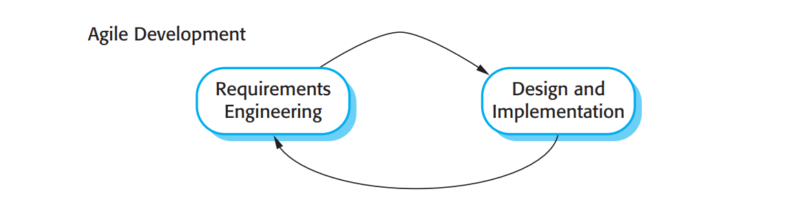

Fig. 3.1: Shows Agile approach to software development.

The choice of Agile development as the software development used in this system is because of the following reasons;

1. Customer involvement in the development process; the client of this system was part of the development process with their stories as requirements.
2. The system is developed in a series of versions. The client is involved in specifying and evaluating each version. They propose changes to the software and new requirements that should be implemented in a later version of the system.
3. The processes of specification, design, and implementation are interleaved. There is no detailed system specification, and design documentation is minimized. The user requirements document only defines the most important characteristics of the system, such as; categories of products, process of making order, validating order etc.
   1. **Requirement Engineering**

The process to gather the software requirement form client, analyze and document them is known as requirement engineering. The goal of requirement engineering is to develop and maintain sophisticated and descriptive system requirement specification document. Two major processes are discussed, namely;

### ***Data Collection***

The major source of requirements is from the client of this system. There are two means by which the system requirements are collected from the client. These are;

1. Summarized requirements documentation: This document consists of major characteristics of the system, such as; system interfaces (home, shop, contact, about, dashboard, login and register pages), shopping cart, filtering products, making order, making payment etc.
2. Interview: Requirements were also collected from the client by means of interview. These are not normal interviews, but discussions (which are considered as user stories) with the programmers during the development process. Some of the requirements collected through this means include; attributes of a product (type, color, category, gender, size, quantity), restocking a product, validating order (making delivery), choice of payment gateway, system policies etc.

### ***Data Analysis***

The requirements collected in the data collection phase are analyzed. The System Design Process (section 3.4) discusses how different UML models were be used in the analysis process.

* 1. **System Design Process**

System design is the process of defining the architecture, components, modules, interface, and data for a system to satisfy the specified requirement. System design could be seen as the application of system theory to product development.

### ***Use case diagram***

Use case diagram are valuable for visualizing the functional requirements of system that will translate into design choices and development priorities. Use case diagrams are valuable UML diagram type and are frequently used to analyze various systems. The three main elements of use case are:

1. Actors: actors are the type of users that interact with the system, in the case of this system they are staff (lecturers) and students.
2. System: Use case capture functional requirement that specify the intended behavior of the system.
3. Goals: Use case is typically initiated by a user (actor) to fulfill a goal describing the activities and variants.

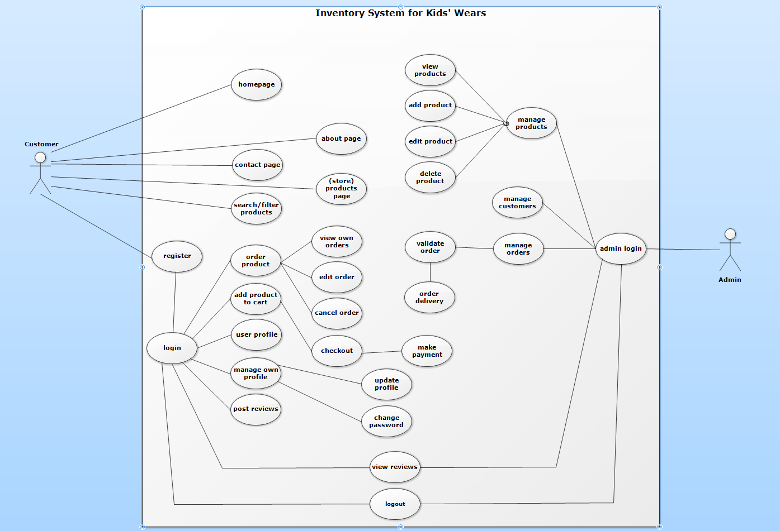

Fig. 3.2: Use Case Diagram.

### ***Entity Relationship (ER) Diagram***

Entity – relationship (ER) diagram is a graphical representation of entities and their relationships to each other typically used in computing in regard to the organization of data within database or information systems. An entity is a piece of data – an – object or concept about which data is stored.

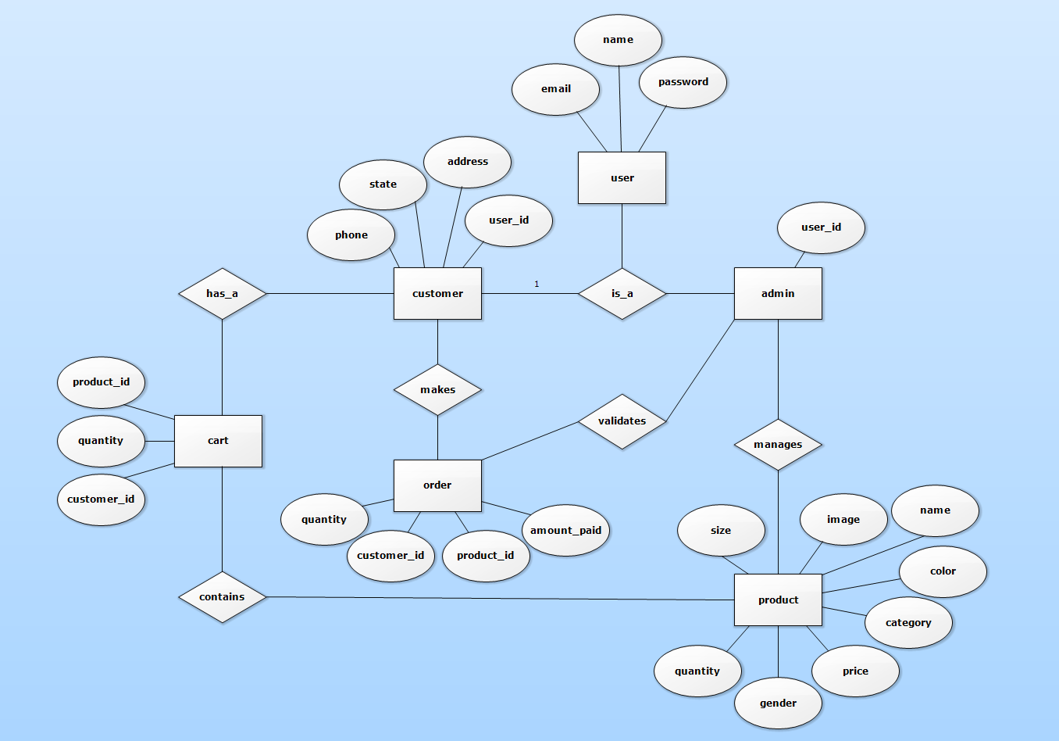

Fig. 3.3: Entity-Relationship Diagram.

### ***Class Diagram***

Class diagrams capture the static structure of the system and act as foundation for other models. They show classes, interfaces, collaborations, dependencies, generalizations, associations, and other relationships. Class diagrams are a very useful way to model the conceptual database schema. A class diagram is displayed as a box that includes three sections: the class name, the attributes, and the operations that can be applied to individual objects of the class.

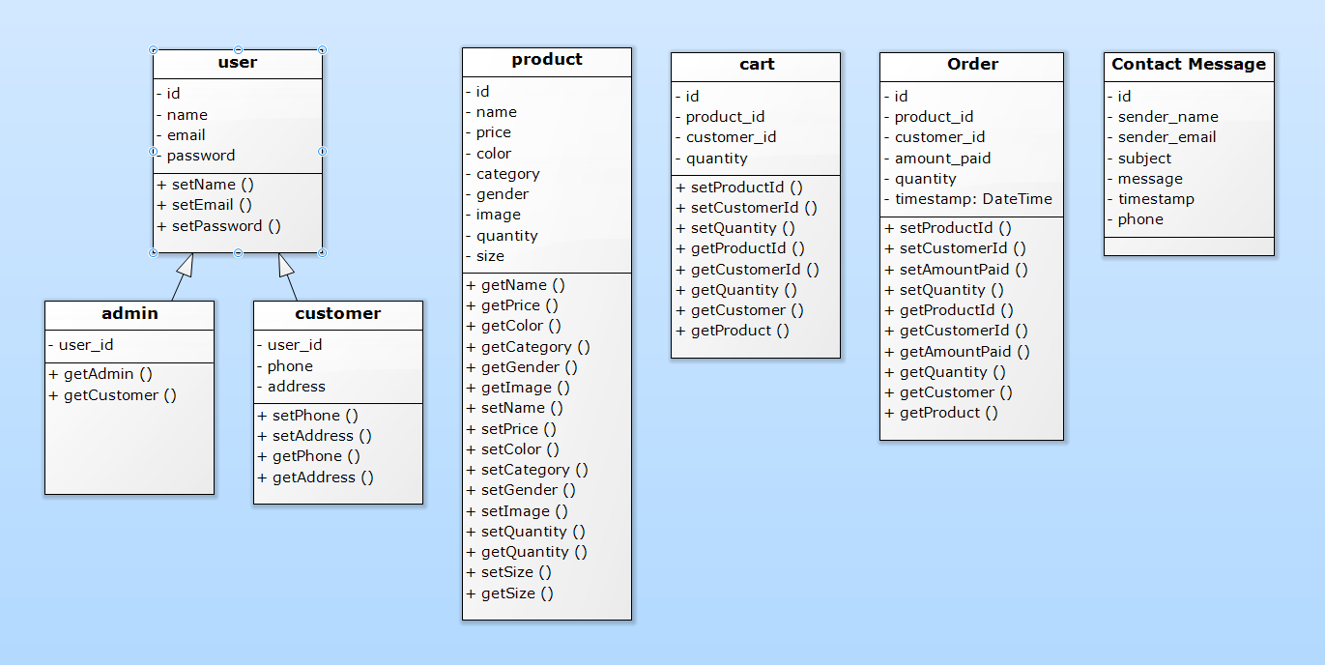

Fig. 3.4: Class Diagram.

**CHAPTER FOUR**

# **SYSTEM IMPLEMENTATION AND RESULTS**

* 1. **Introduction**

A product software implementation method is systematically structured approach to effectively integrate a software-based service or components into the workflow of an organizational structure or an individual end-user.

* 1. **Technical tools used**

The following are some of the tools used in the design, development and implementation of this system;

### ***Hardware used***

1. A PC with internet connection.

### ***Software used***

1. Laravel framework (Laravel 10)
2. Windows Operating System. (Windows 10)
3. XAMPP Server (v3.3.0).
4. PHP version 8.
5. Microsoft Edge and Google Chrome browsers.
6. MYSQL Database.
7. Node.js (version 14)
8. Git version control and GitHub.
   1. **System Testing**

Software testing is an investigation conduct to provide stakeholder with information about the quality of the software or service under test. Software testing can also provide an objective, independent view of the software to allow the business to appreciate and understand the risks of the software implementation. Test technique includes the process of executing a program or application with intent of finding software bugs (error or other defects), and verifying that the software is fit for use.

Table 4.1: System testing.

|  |  |  |  |  |  |  |
| --- | --- | --- | --- | --- | --- | --- |
| Test ID | Test Name | Test Data | Expected Result | Actual result | Comments | Test type |
| 1 | Login check | Correct login details | Should be logged in | Logged in | Test is okay | Black box |
| 2 | Login check | Incorrect login details | Should not be logged in | Didn’t log in | Test is okay | Black box |

* 1. **System Requirement**

### ***Software Requirement***

1. PHP
2. HTML
3. CSS
4. Bootstrap
5. The Laravel Framework for Web Artisans v10
6. XAMPP Control v3.3.0
7. MYSQL Database
8. Microsoft Edge or Google Chrome browser.

### ***Hardware Requirement***

1. Keyboard
2. Mouse
3. RAM at least 1GB
4. Hard Disk at least 250 GB
   1. **Result**

Better output of software increase user acceptance and implementation success rate higher. This part explains the results as follows;

### ***System Interfaces***

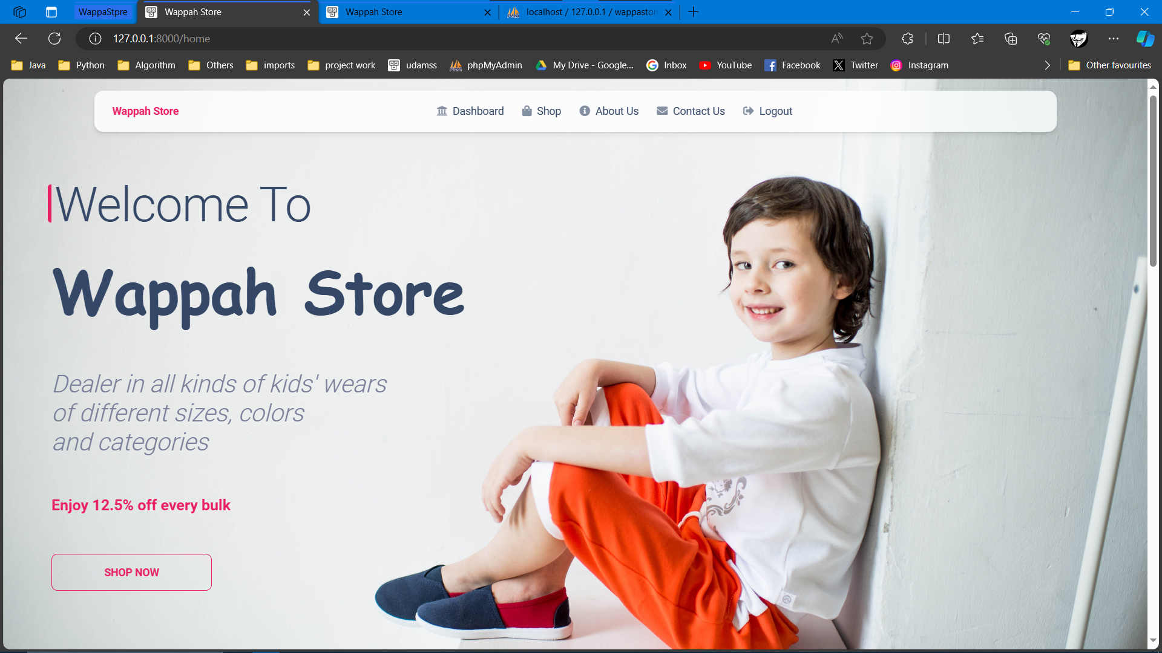

Fig. 4.1: Shows the landing page (homepage).

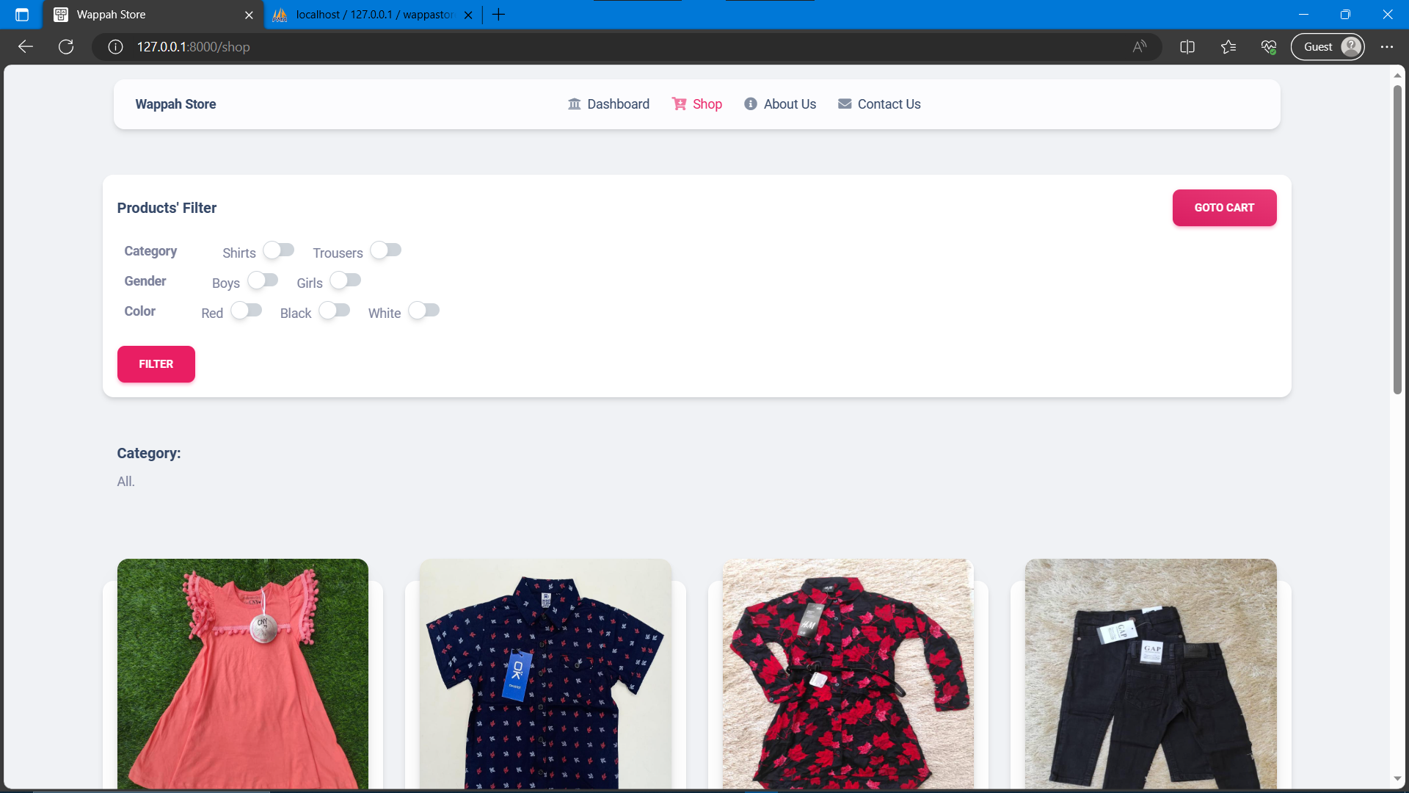

Fig. 4.2: Shows the shop page (products).

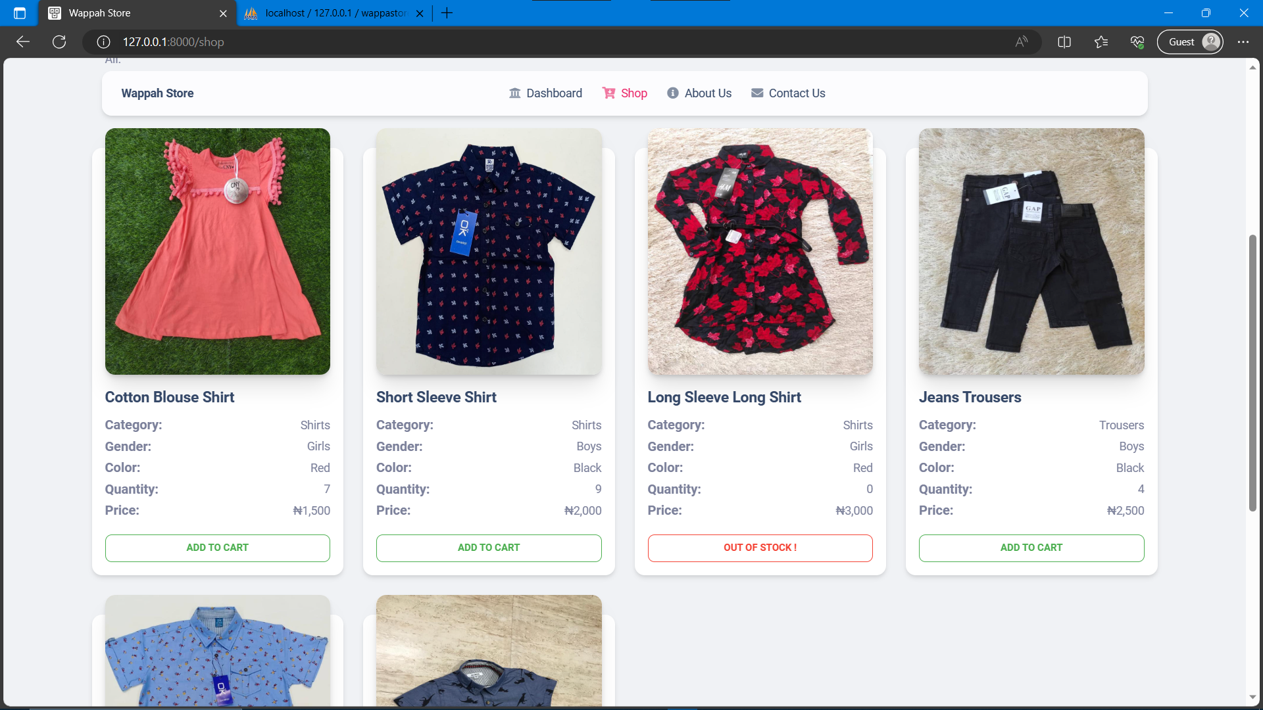

Fig. 4.3: Shows the shop page (more products).

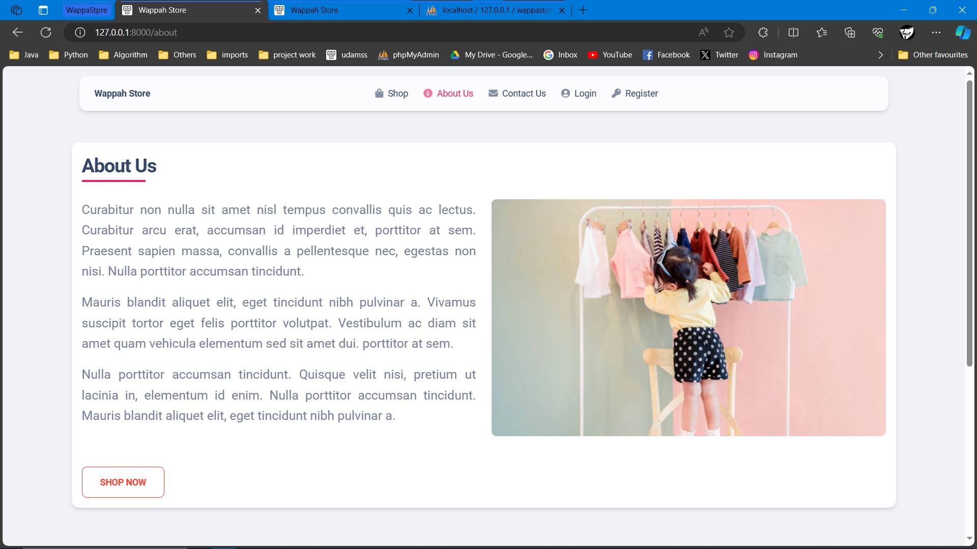

Fig. 4.4: Shows the about page.

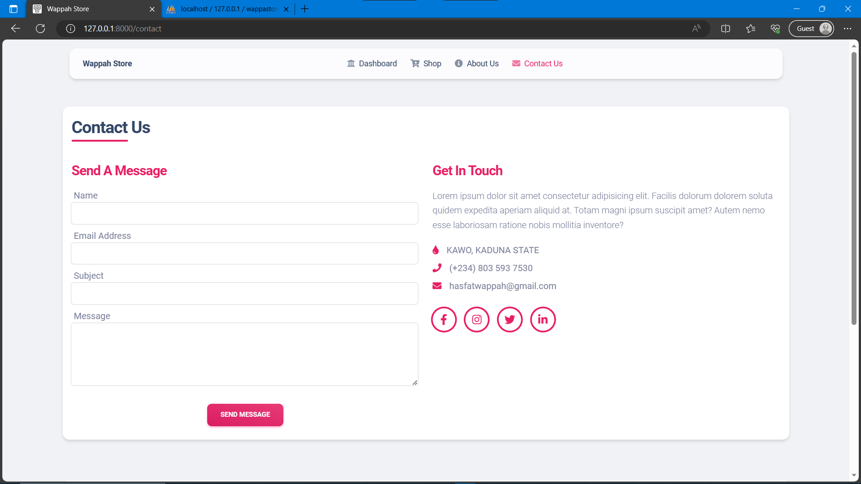

Fig. 4.5: Shows the contact page.

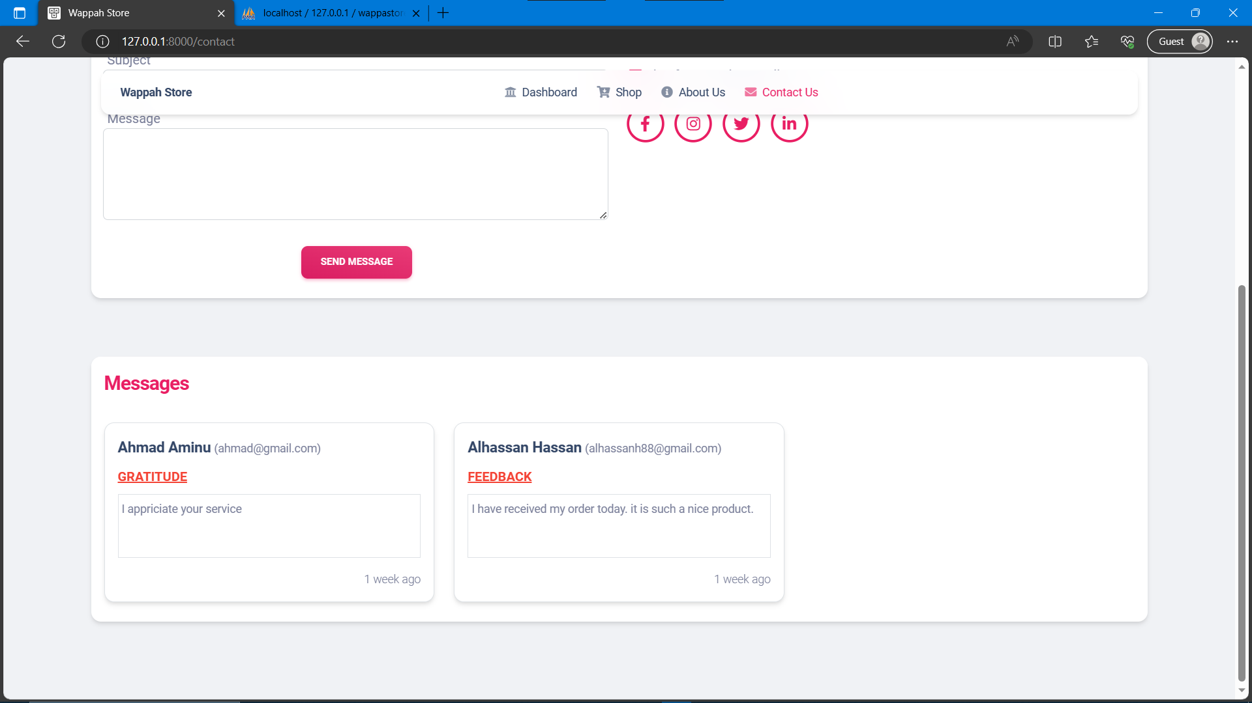

Fig. 4.6: Shows the contact page (messages sent by customers).

### ***Registration***

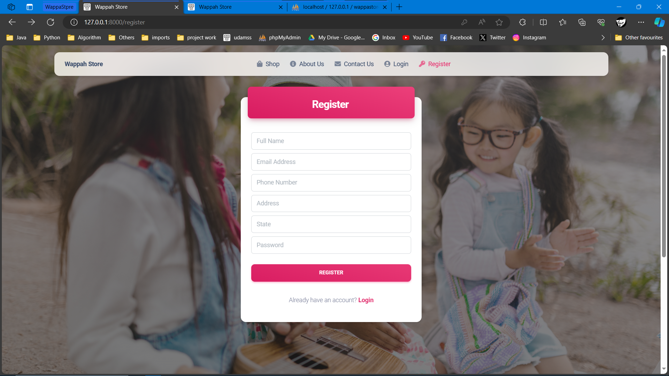

Fig. 4.7: Shows the customer registration page.

### ***Authentication (Login)***

The means of authenticating the users of this system is using the email address and password. Both admin and customers can login through the same login page. However, they get redirected to different dashboards. The figure below shows the login page.

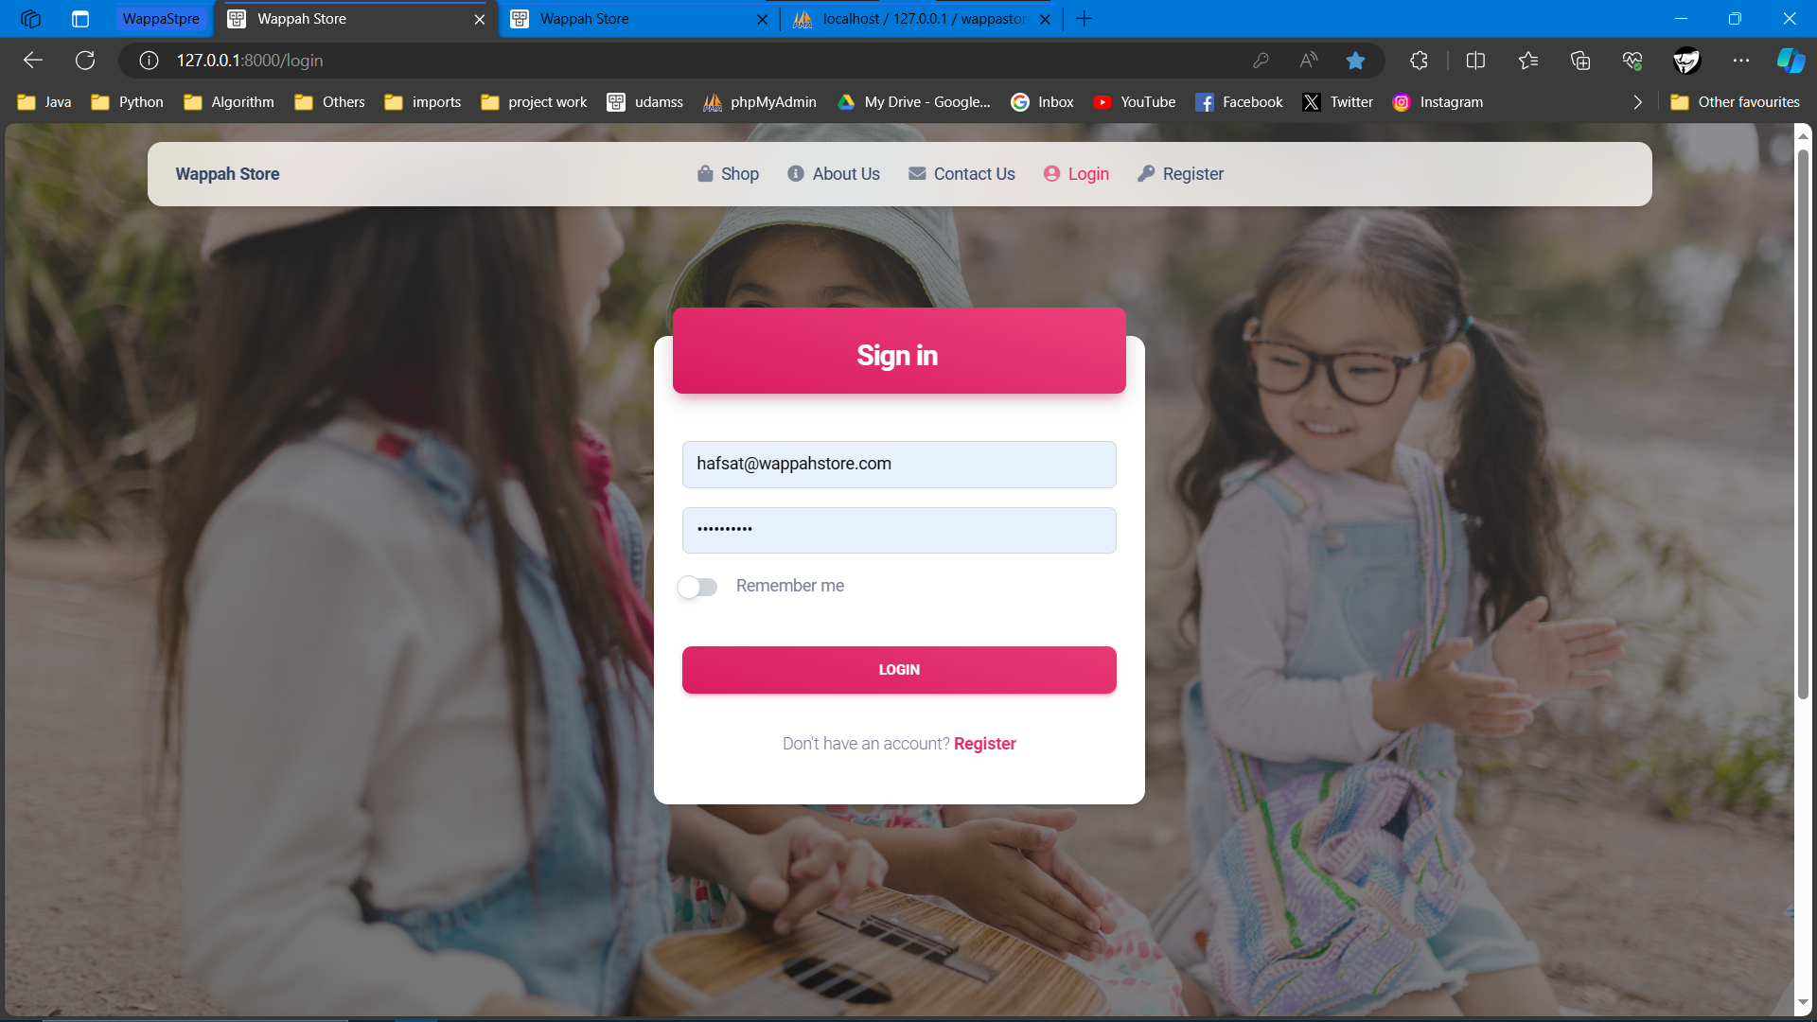

Fig. 4.8: Login page.

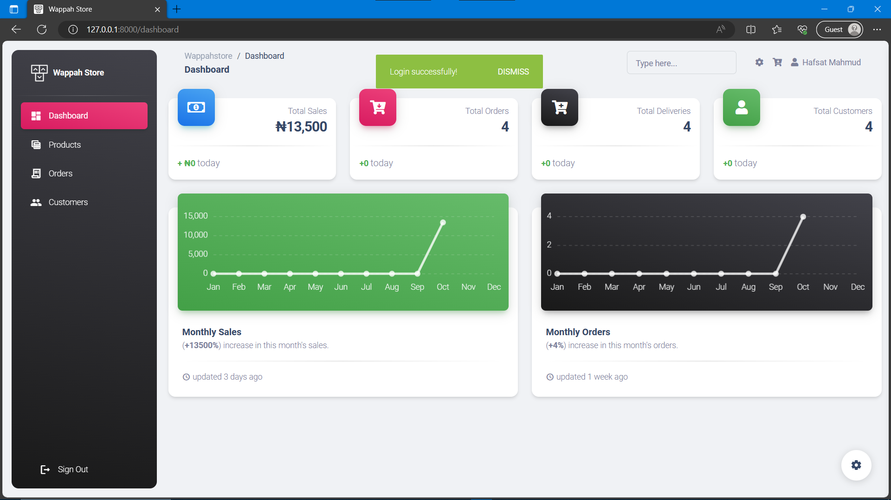

Fig. 4.9: The admin dashboard after a successful login.

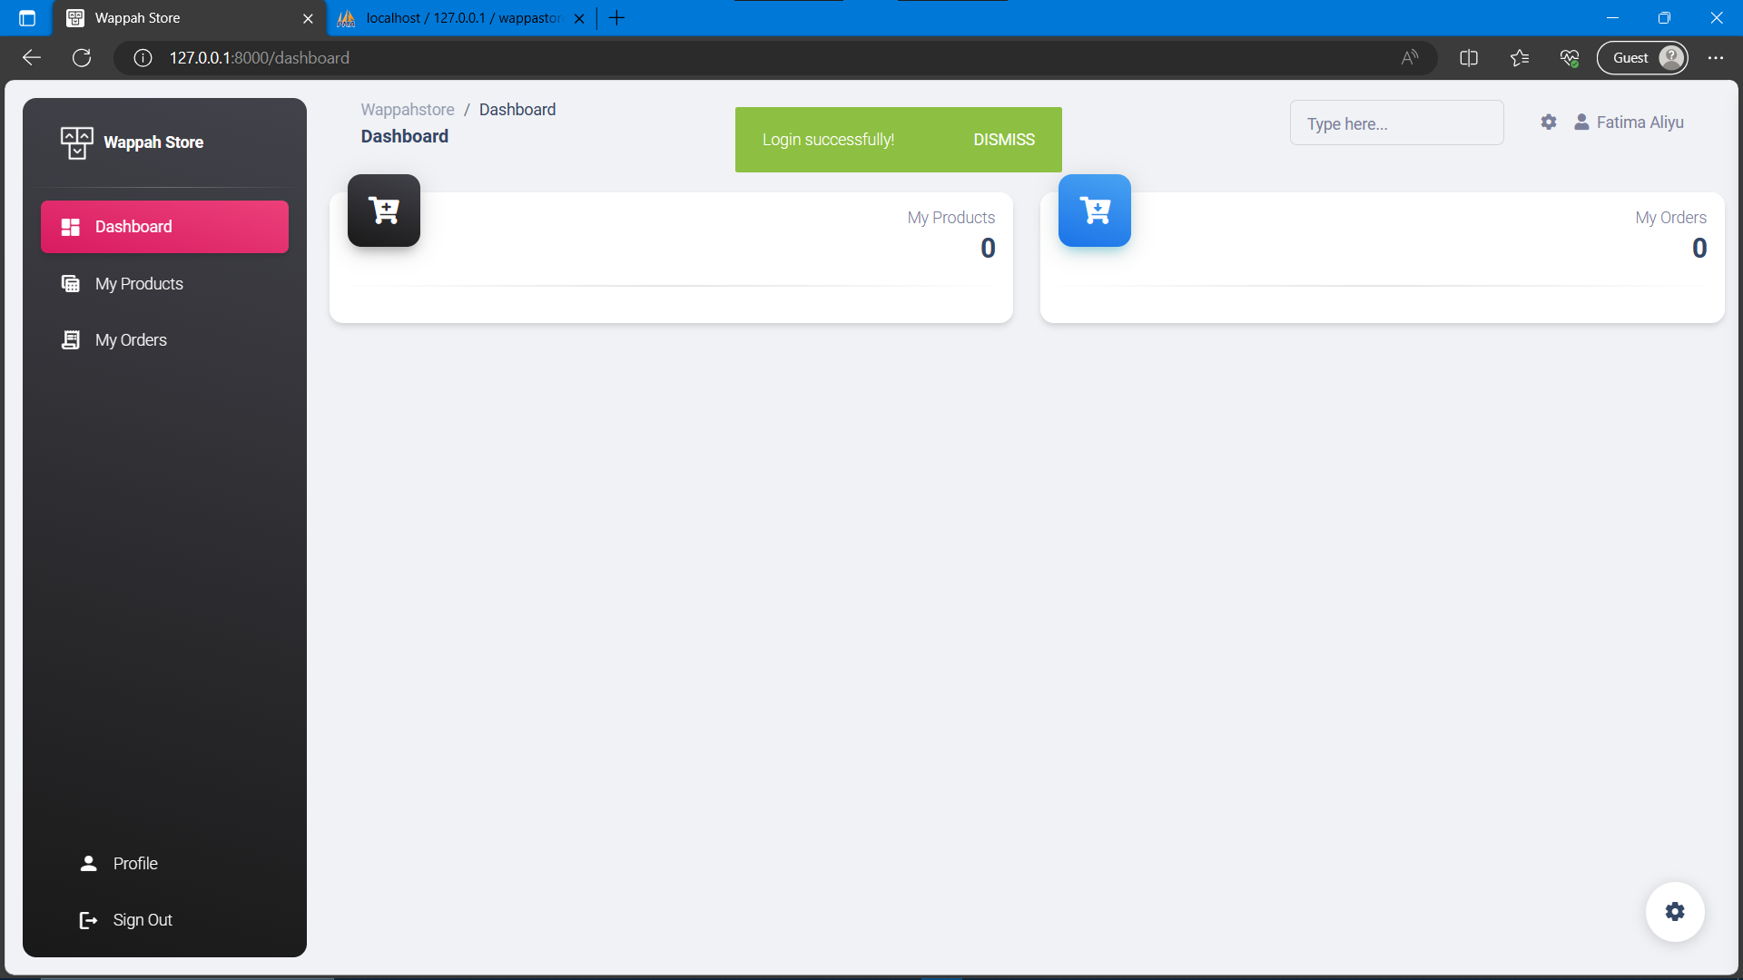

Fig. 4.10: The customer dashboard after a successful login.

### ***Managing Shopping Cart***

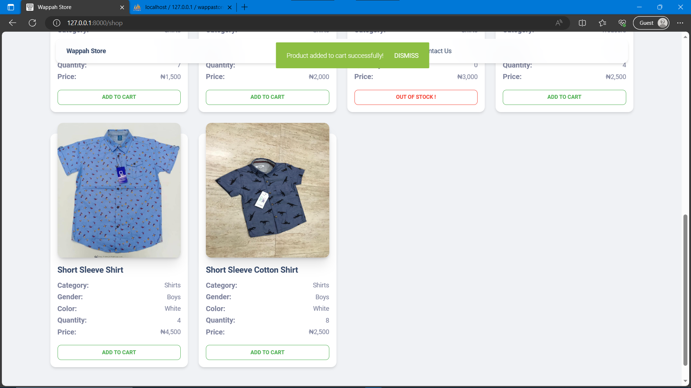

Fig. 4.11: Shows the process of adding products to shopping cart.

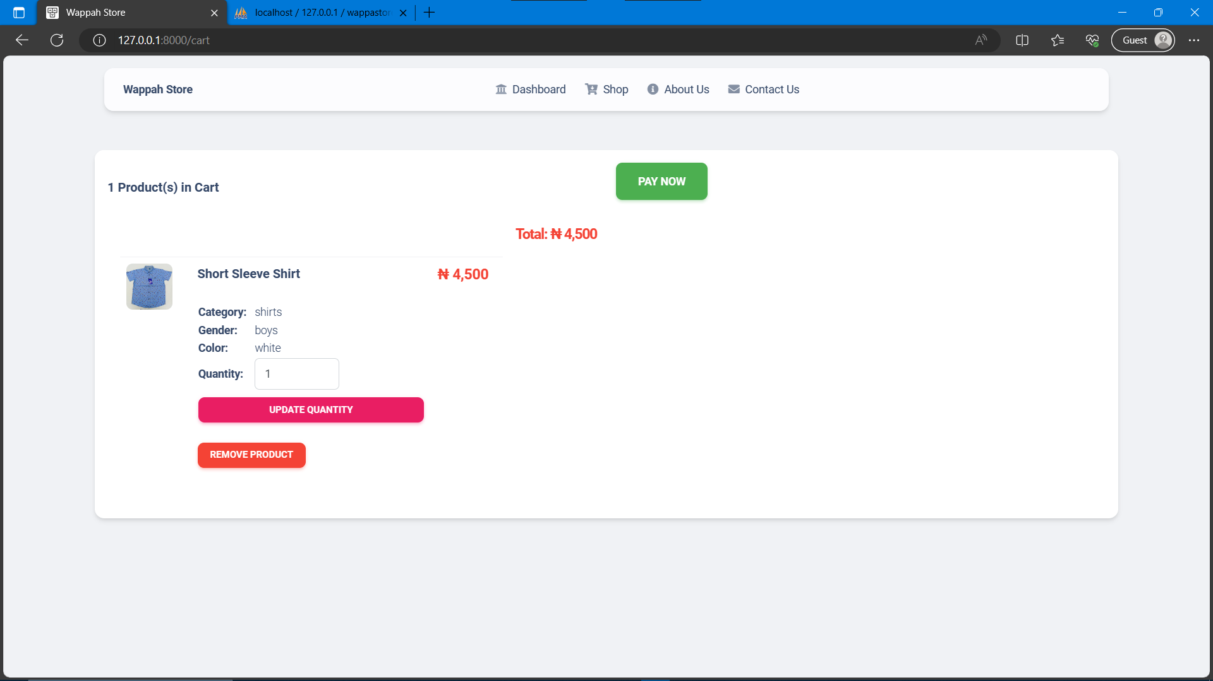

Fig. 4.12: Shows the shopping cart.

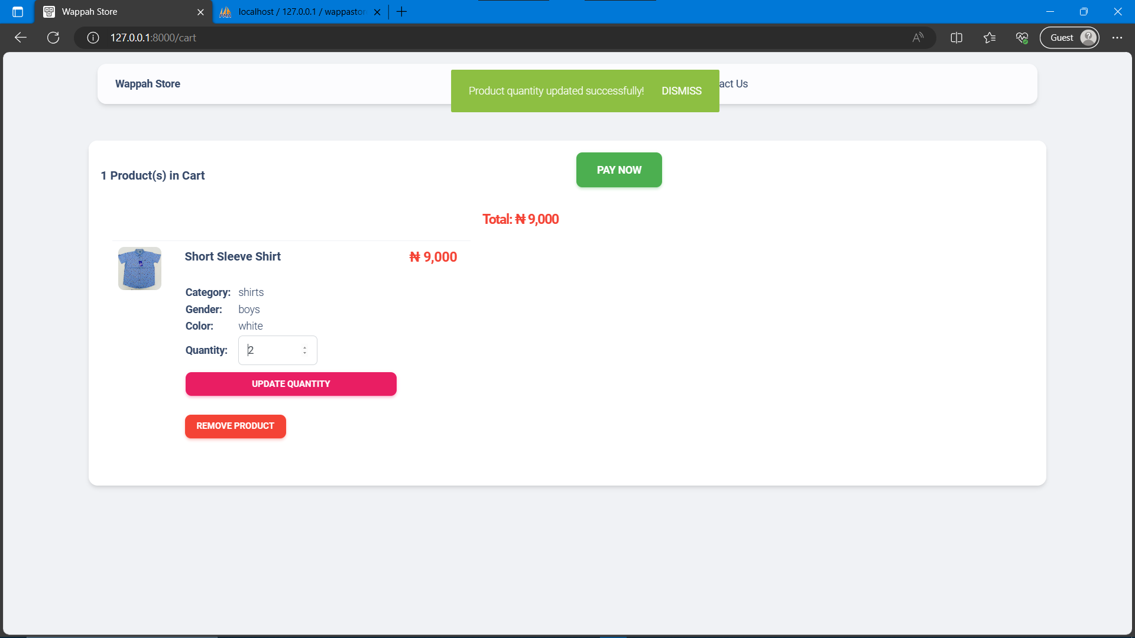

Fig. 4.13: Shows the process of updating the quantity of products in the shopping cart.

### ***Making Order & Payment***

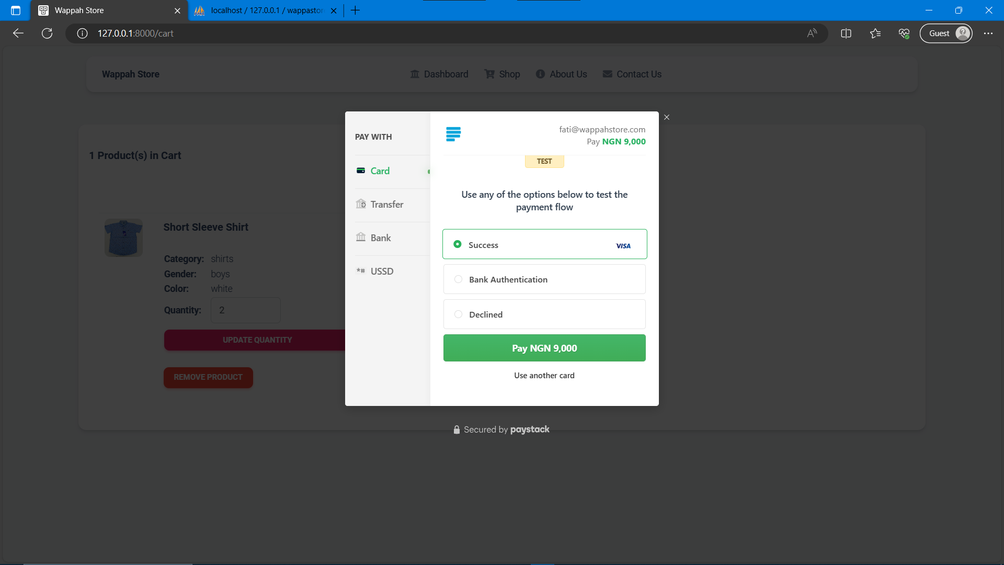

Fig. 4.14: Shows the process of paying for products in the shopping cart.

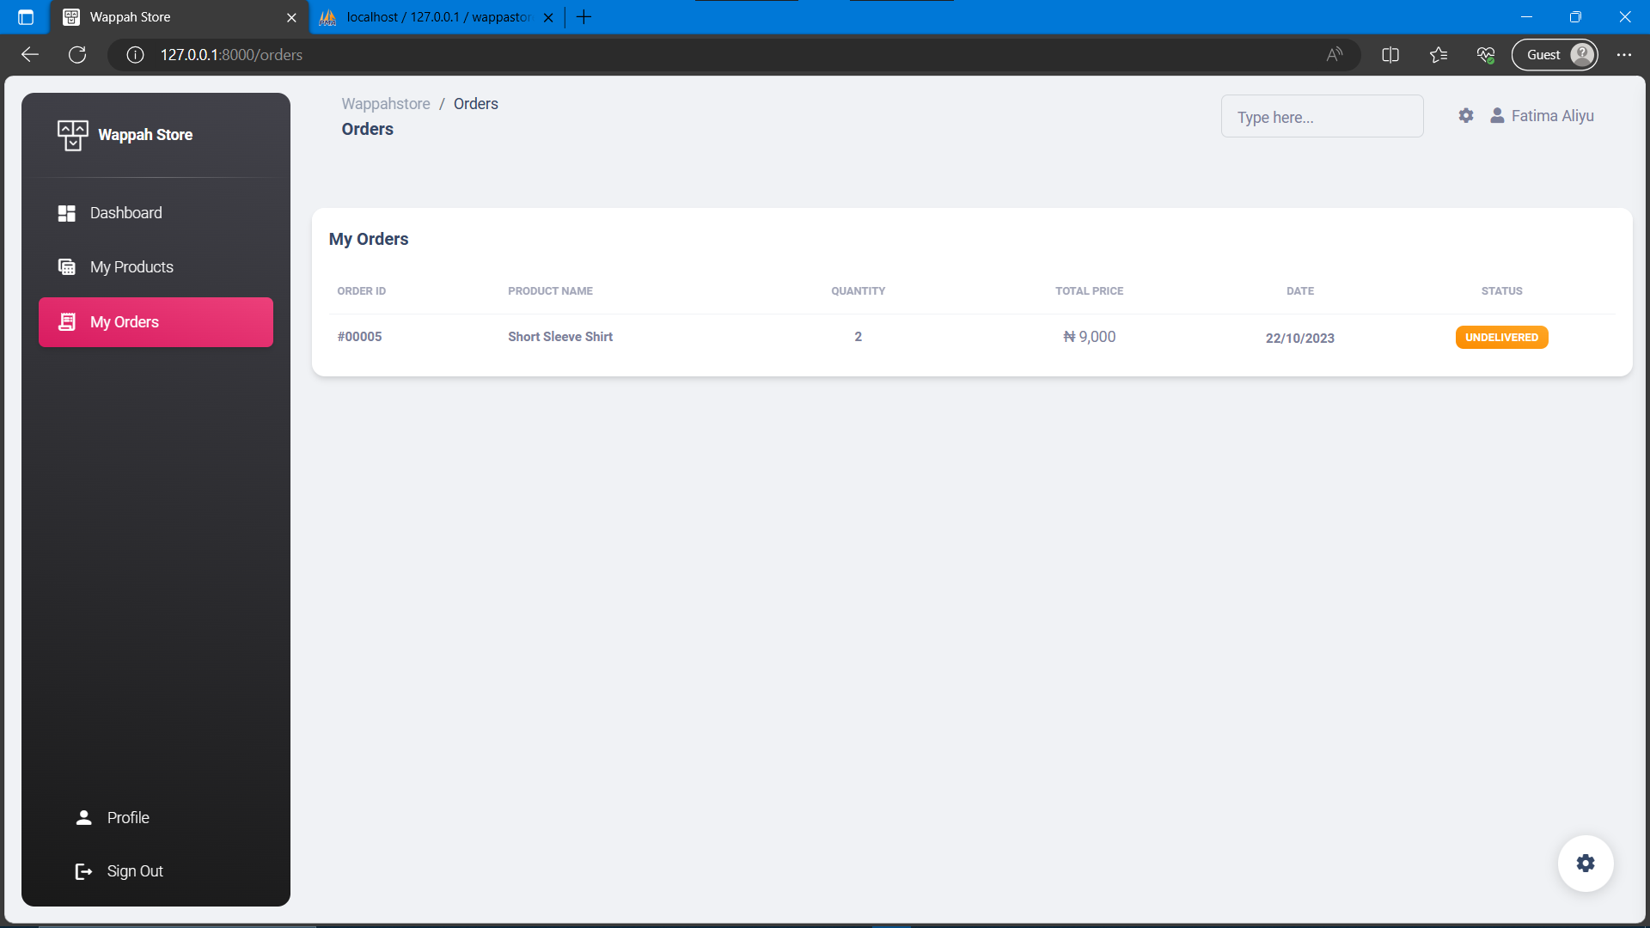

Fig. 4.15: Shows the orders made by a customer.

After a successful payment. A customer is redirected to the orders page in their dashboard, so as to enable them see the order they just placed.

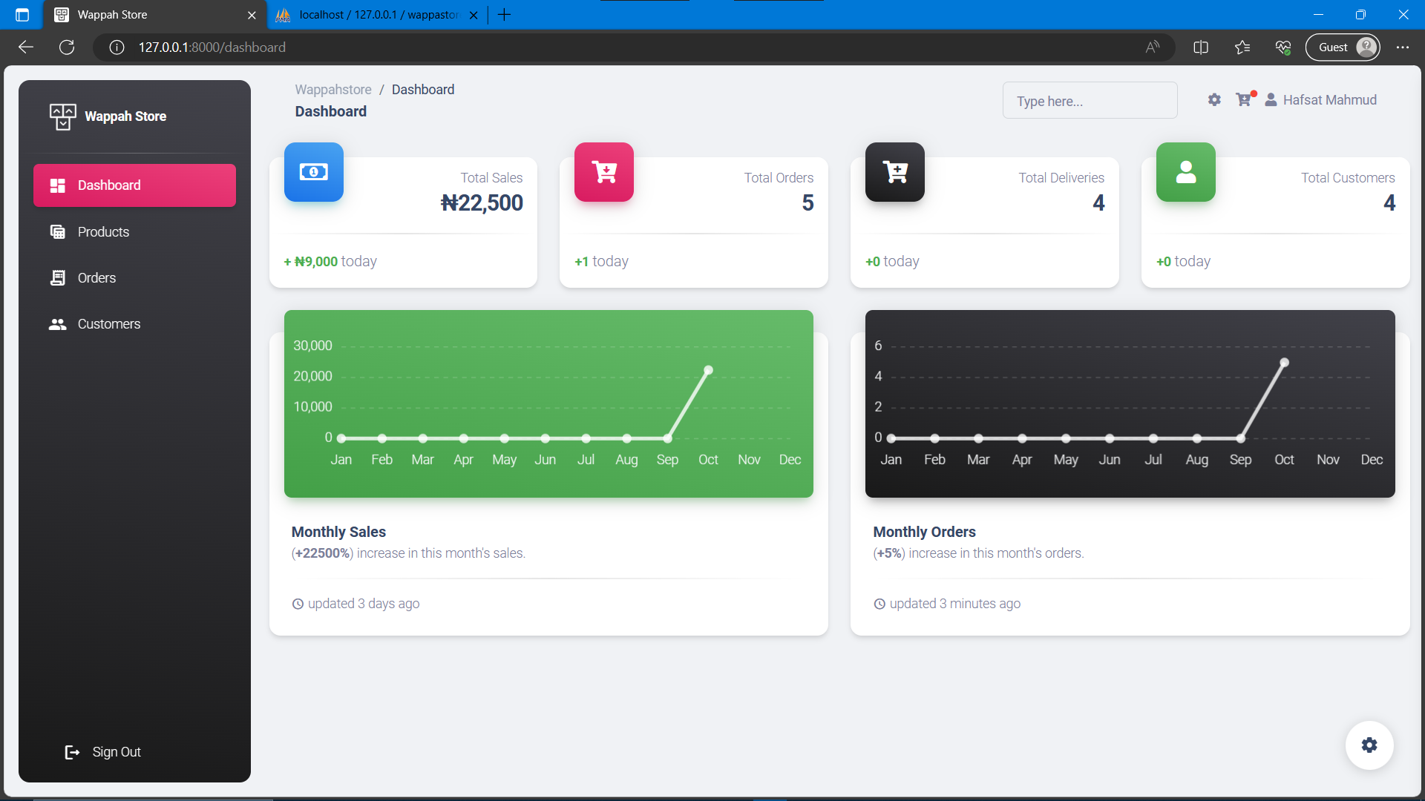

Fig. 4.16: Shows the admin dashboard responding to the activities of customers on the system.

### ***Managing Products***

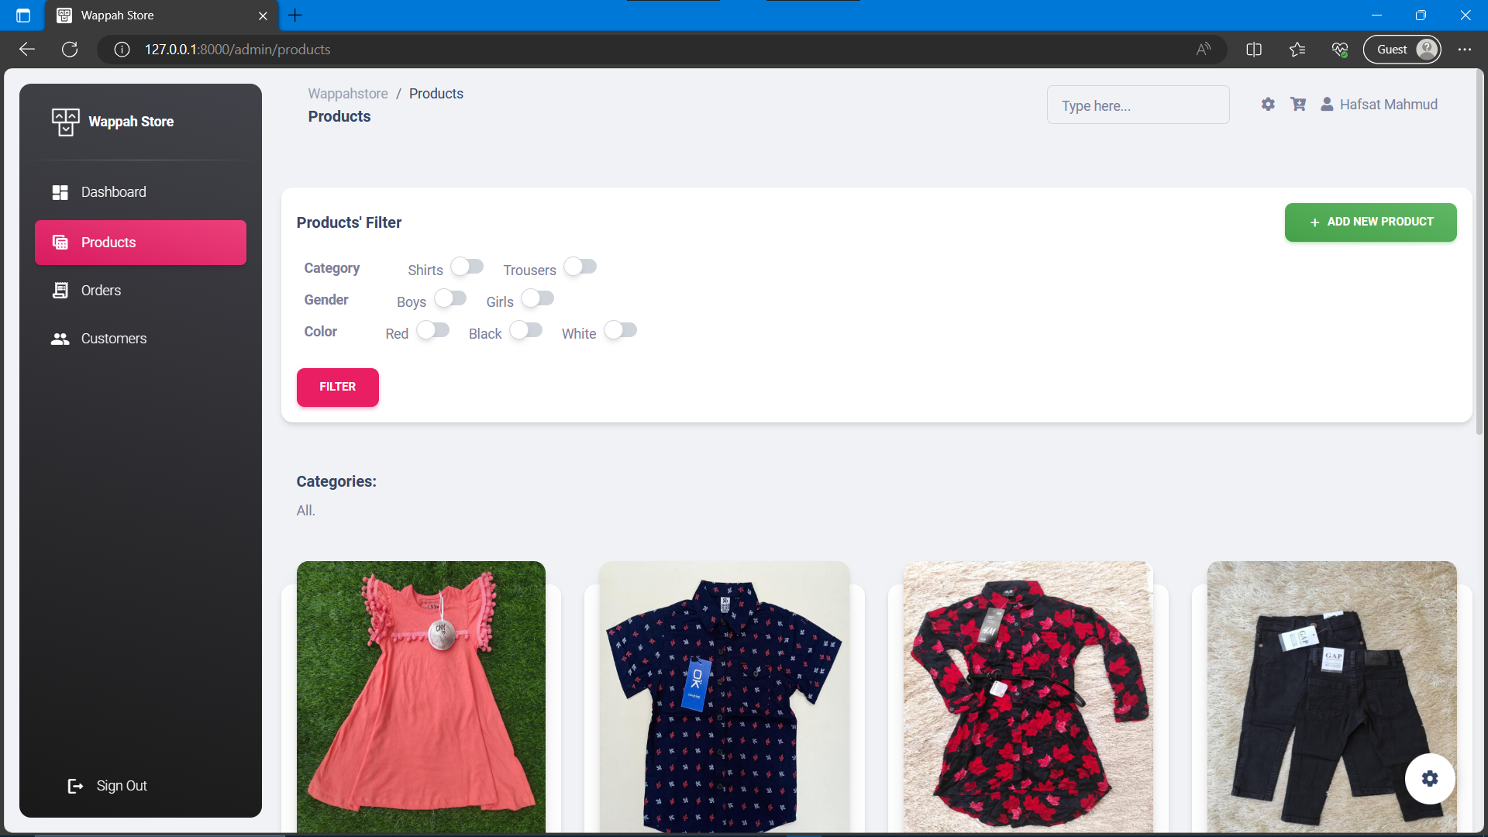

Fig. 4.17: Shows the product management (Admin dashboard).

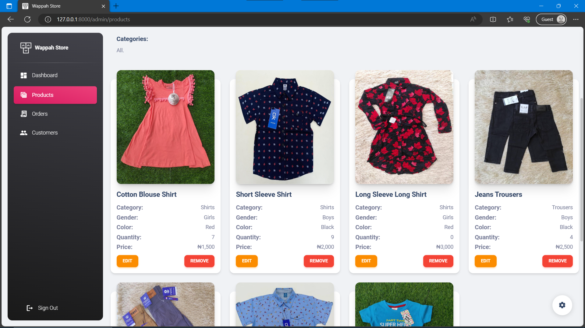

Fig. 4.18: Shows the product management (Admin dashboard).

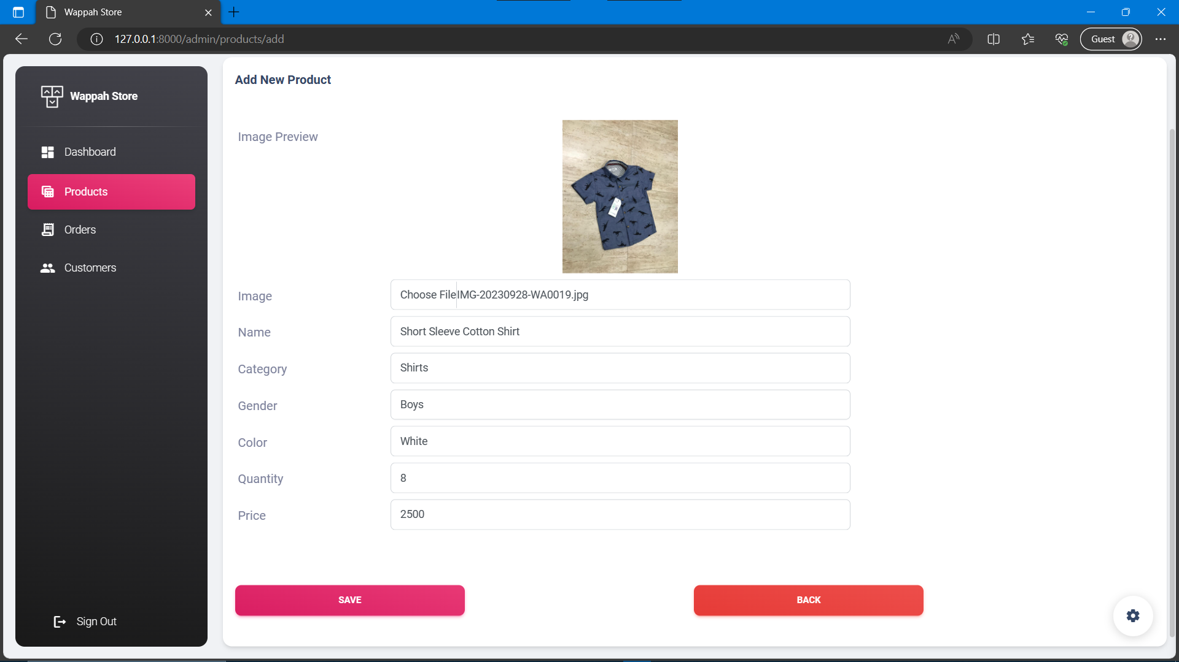

Fig. 4.19: Shows the process of adding a product.

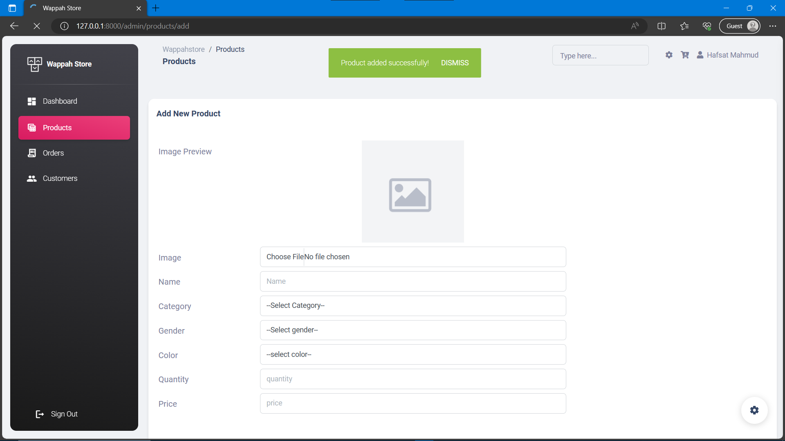

Fig. 4.20: Shows the result of adding a product.

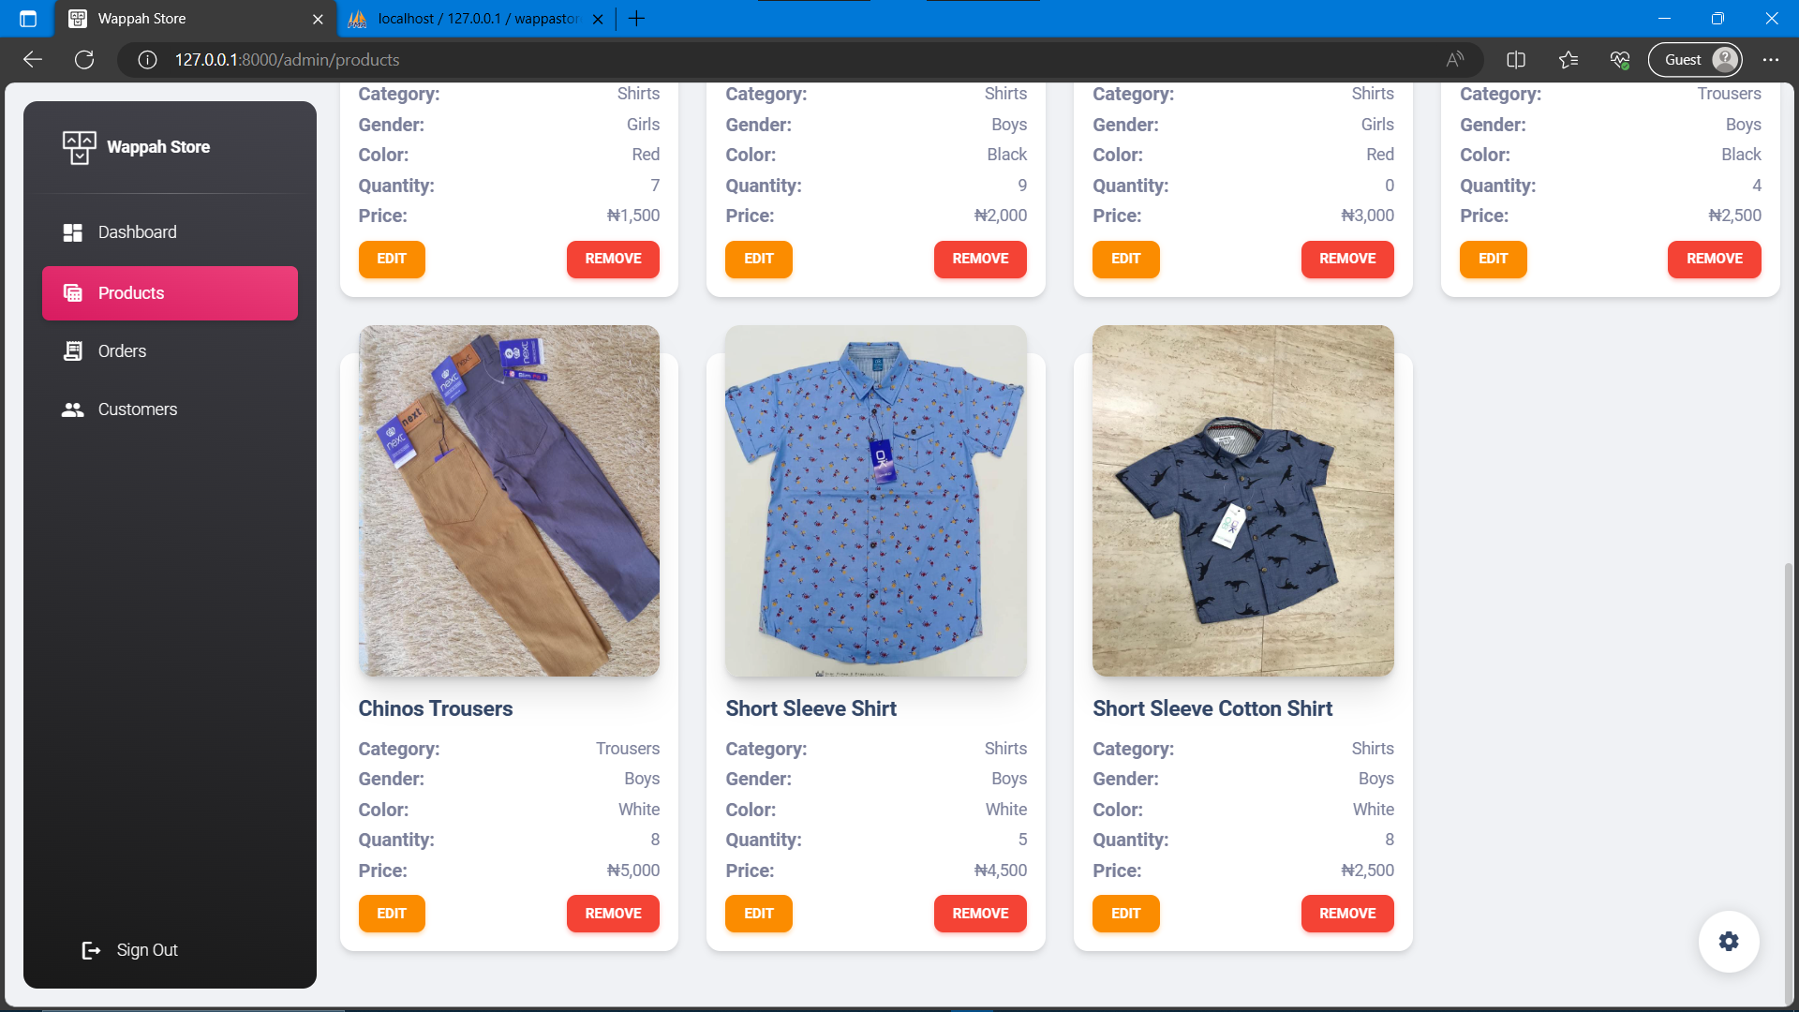

Fig. 4.21: Shows the result of adding a product.

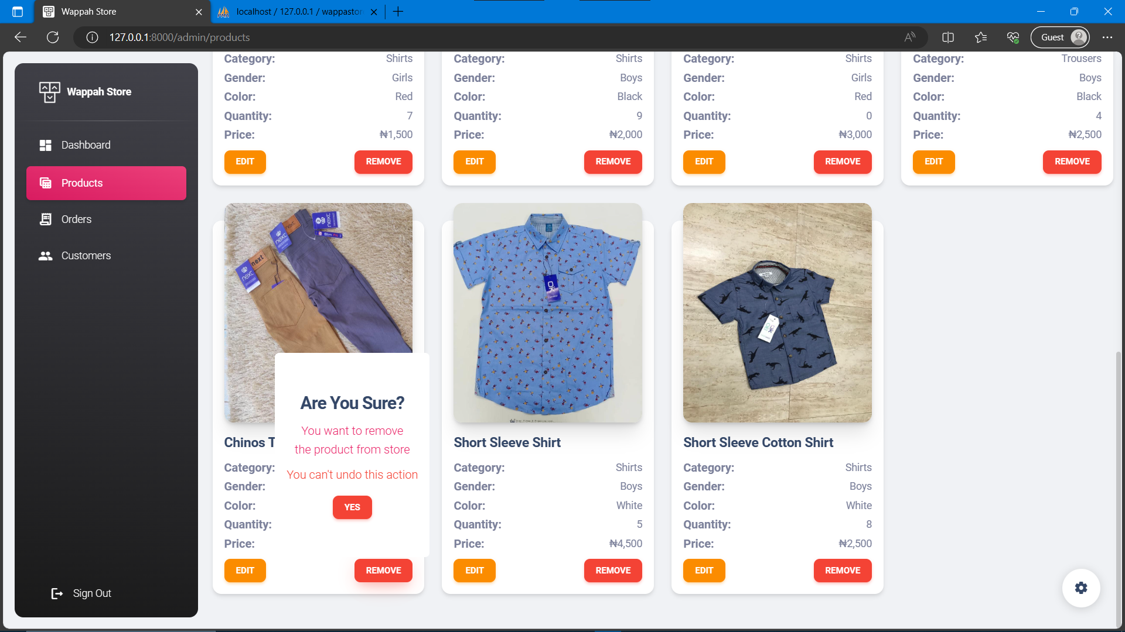

Fig. 4.22: Shows the process of deleting a product from the shop.

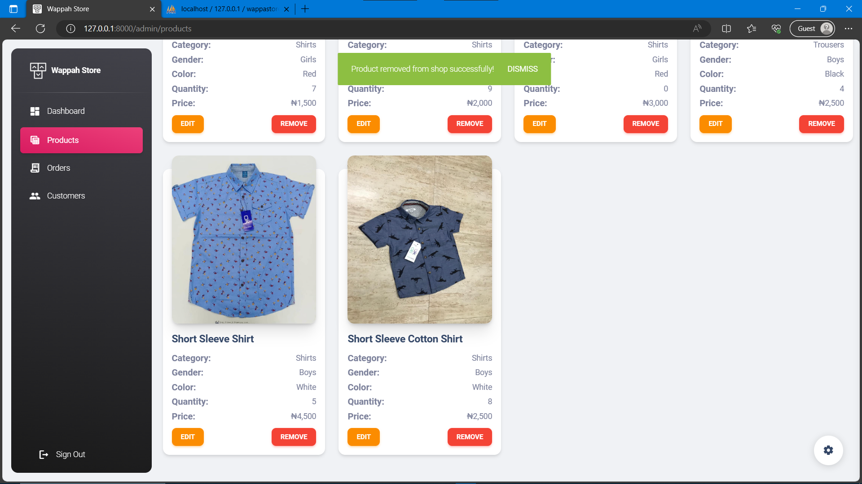

Fig. 4.23: Shows the result of deleting a product from the shop.

### ***Managing Orders***

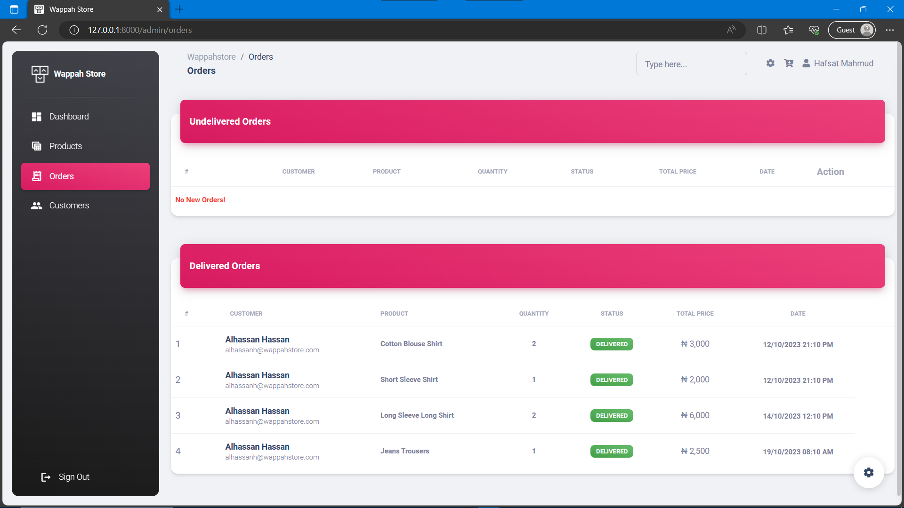

Fig. 4.24: Shows the product management (Admin dashboard).

Whenever a customer makes an order (makes a payment), or the admin validates an order. The charts in dashboards of the customer and the admin reflect those activities. The figure below shows the result of order placed in figures above.

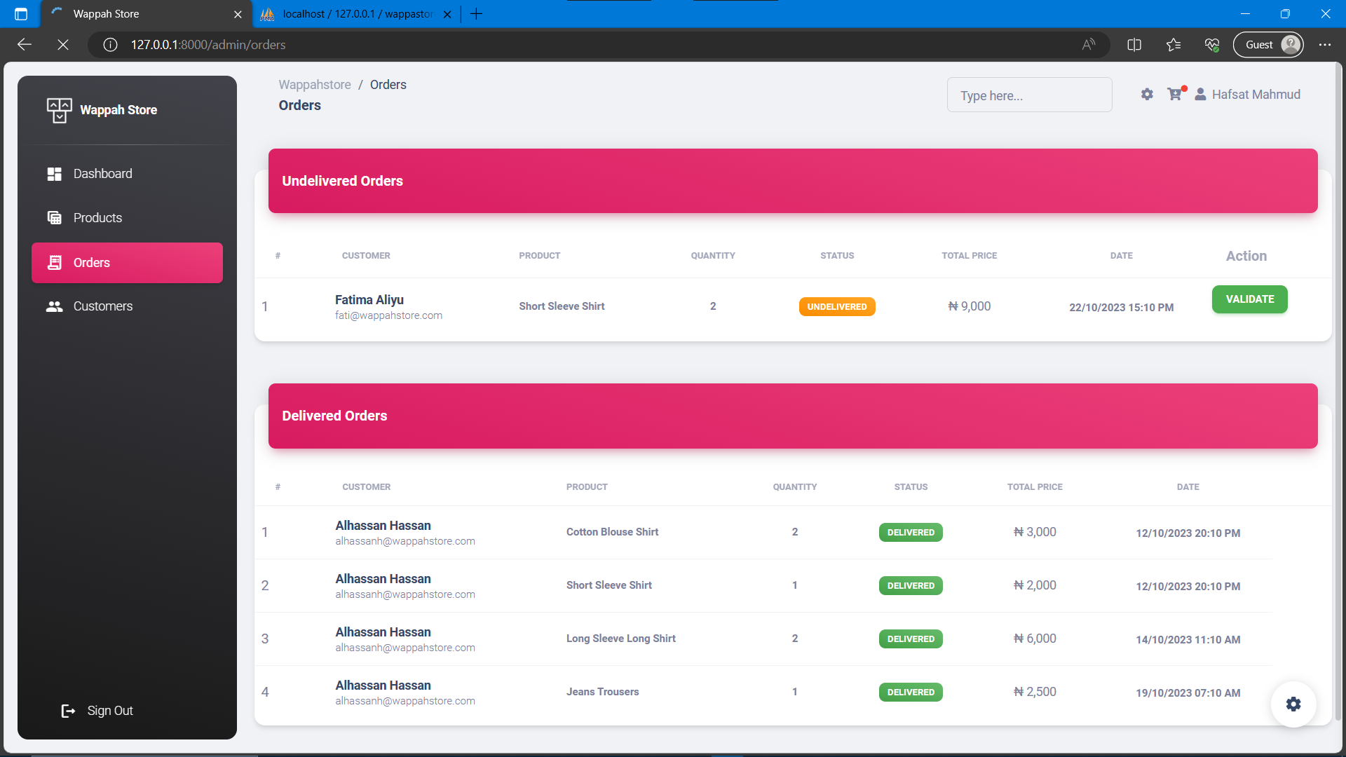

Fig. 4.25: Shows the orders placed by customers (viewed by the admin).

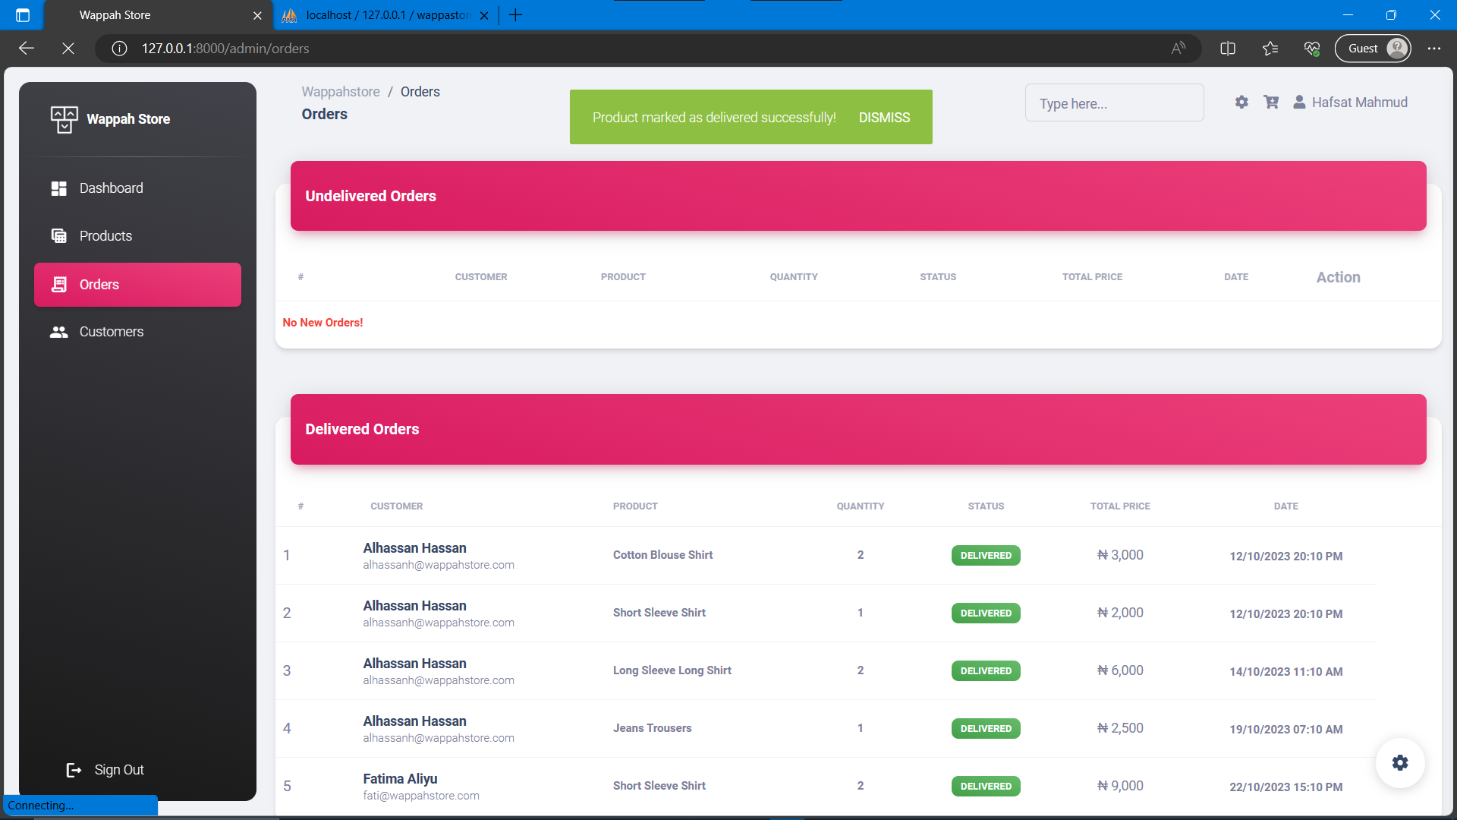

Fig. 4.26: Shows the result of validating an order by the admin.

### ***Managing Customers***

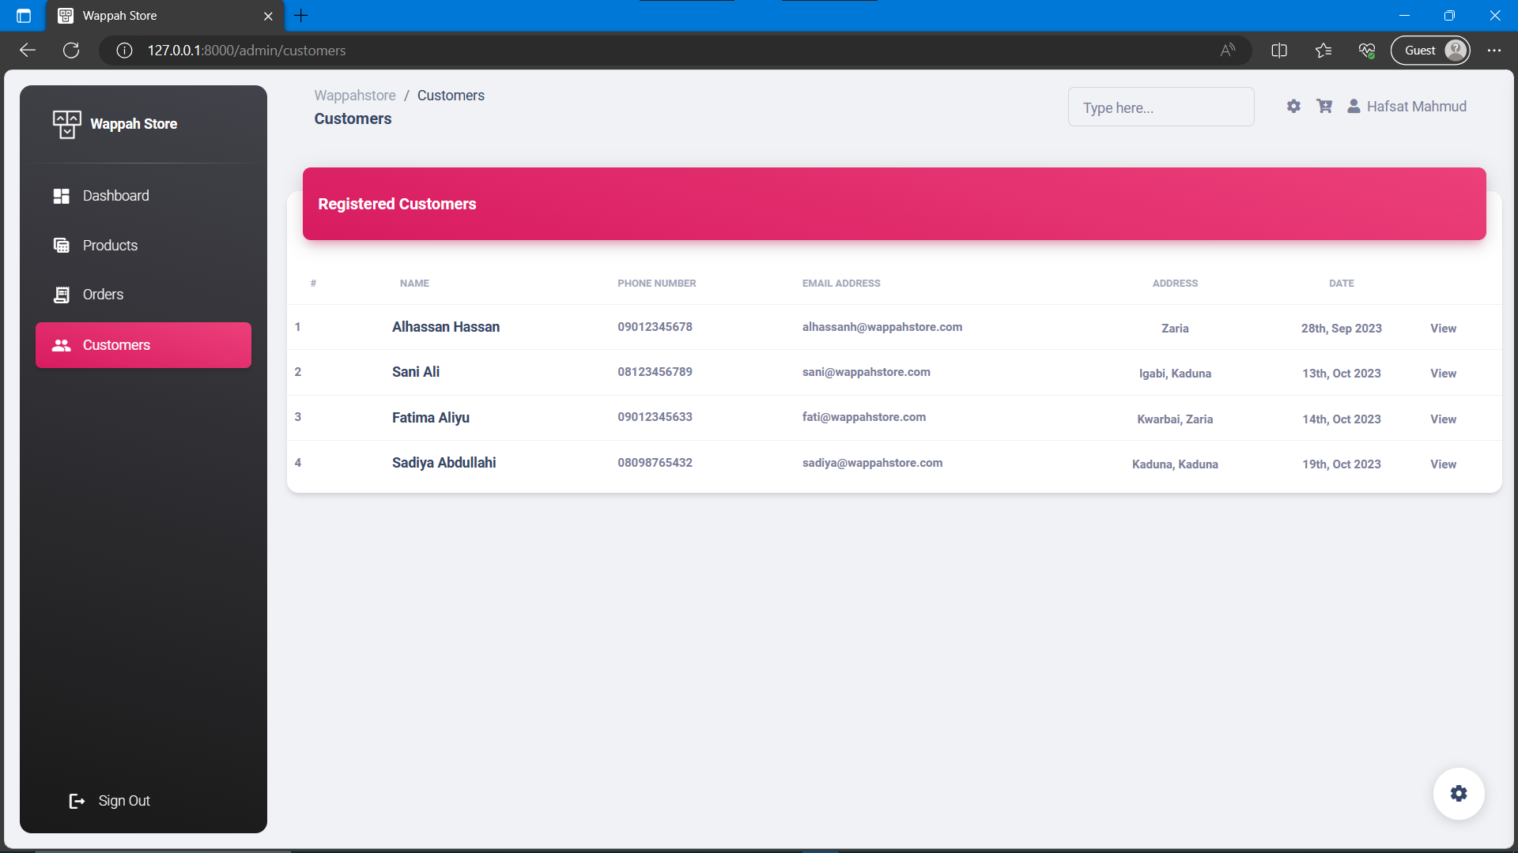

Fig. 4.27: Shows the list of registered customers.

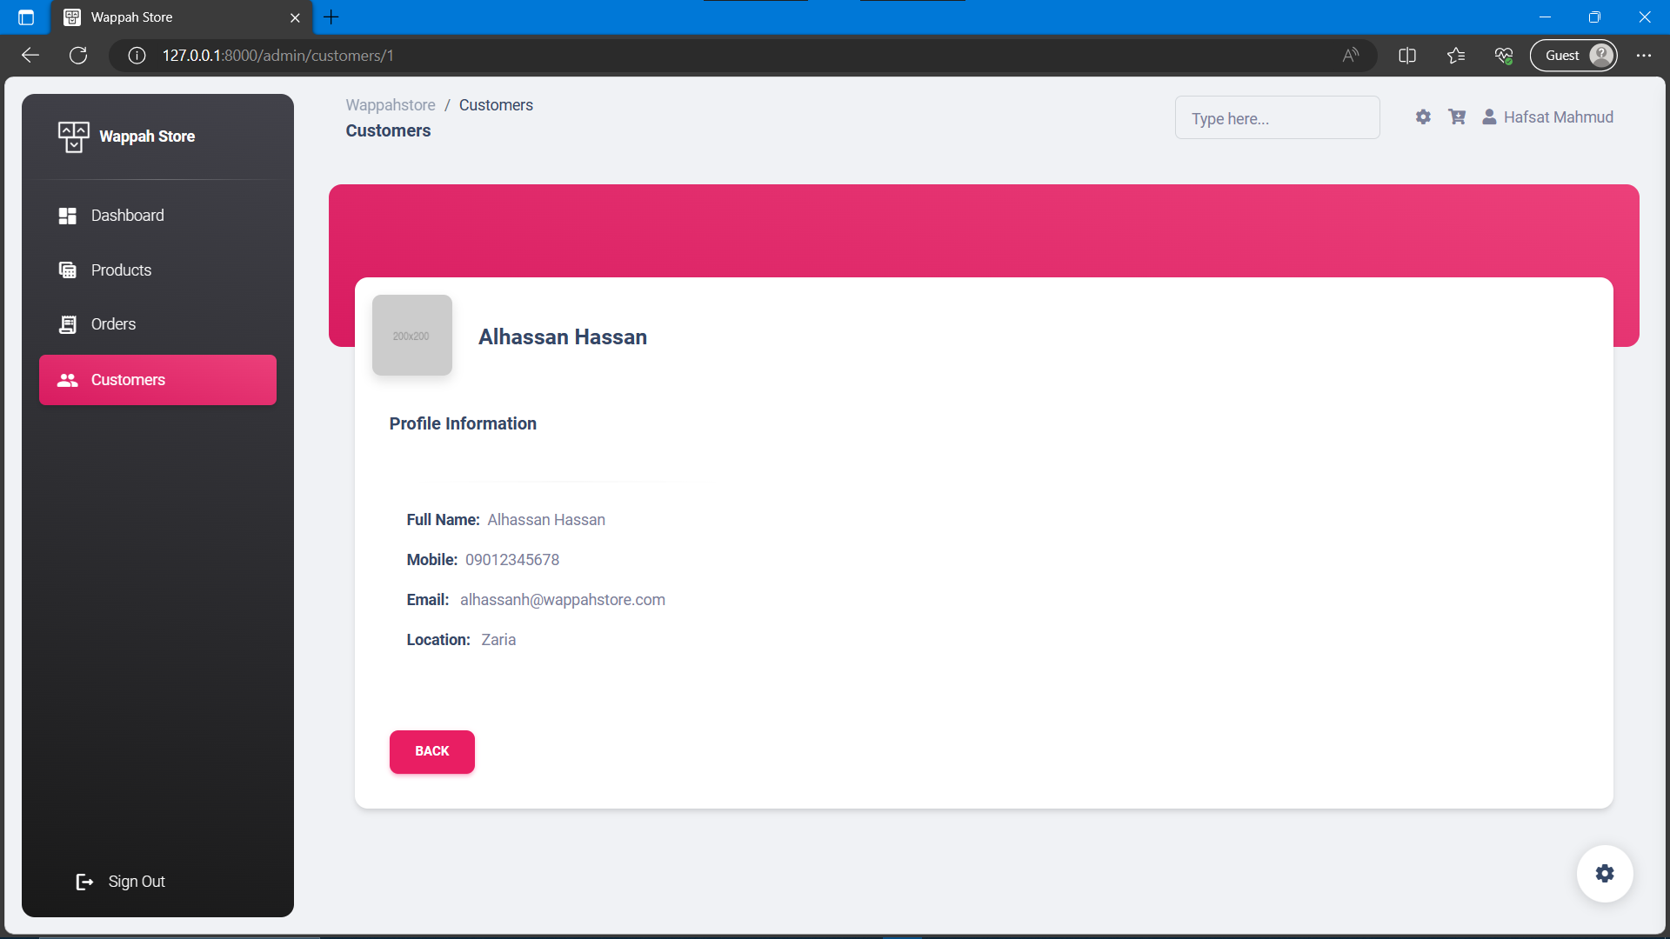

Fig. 4.28: Shows the profile of a registered customer.

**CHAPTER FIVE**

# **SUMMARY, CONCLUSIONS AND RECOMMENDATIONS**

* 1. **Summary**
  2. **Conclusions**
  3. **Recommendations**

# **REFERENCES**

Ballou, R.H. (2004). Business Logistics / Supply Chain Management. Planning, Organising and Controlling the Supply Chain. 5th edition. *PEARSON-Prentice Hall.US*.

Chase, R. B., Jacobs, F. R. & Aquilano, N. J. (2004). Operations Management for Competitive Advantage. 10th edition. International edition. *M C GRAW HILL. NY*.

Gautam, R. and Kumar, A. (2020). Inventory Control System. *International Journal of Engineering and Technology (IRJET).* Vol. 07 Issue: 07 p. 1140 – 1143.

Goetschalckx, M. (2011). Supply Chain Engineering. New York, USA: Springer.2004). Warehouse Management Systems. World Trade, Vol.17 Issue 6, p60-66.

Kumar, N. (2015). Inventory Management System. *International Journal of Innovative Research in Technology (IJIRT).* Vol. 2 Issue: 6 p. 281 – 285.

Matsebatlela, A., Molebogeng, G. and Khumbulani, M. (2015). Inventory Management framework to minimize supply & demand mismatch on manufacturing organization. *IFAC-Paper Online* 48.3: 260-265.

Mehta, S.S., Puranik, P.S. and Sharma, S.B. (2016). A Review on Inventory Management System for Improving Efficiency of Project Development Cycle. *Journal of Advanced DatabaseManagement & Systems.* 3(3): p. 24-29.

National Retail Federation, (2019). Inventory Management. Retrieved from <https://nrf.com/resources/inventory-management>

Piasecki, D. (2004). Warehouse Management Systems. World Trade, Vol.17 Issue 6, p60-66

Pycraft et al. (2000). Operations management. Southern Africa edition. *Pearson education. South Africa.*

Stock, J. R. & Lambert, D. M. (2001). Strategic logistics management. 4th edition. M C Graw Hill. International edition. Marketing / Advertising series.

Tommey, J. W. (2014). Inventory Management: Principles, Concepts and Techniques. *Boston/Dordrecht/London: Kluwer Academic Publishers*. P. 1-8.

Wilson, D. (2016). Warehouse Management Systems. Dairy Foods, pp. Vol.107 Issue 8, p100.

Zsofia, K. (2015). How to Optimize Warehouse Management & the Inventory Level in the fast- moving Fashion Industry (Focusing on the effect of inventory system & warehouse management at Sun Enterprises). *Graduation Research Report at International Business & Management Studies, Budapest Business School.*